***procool***  
AV cooling system   
installation instructions

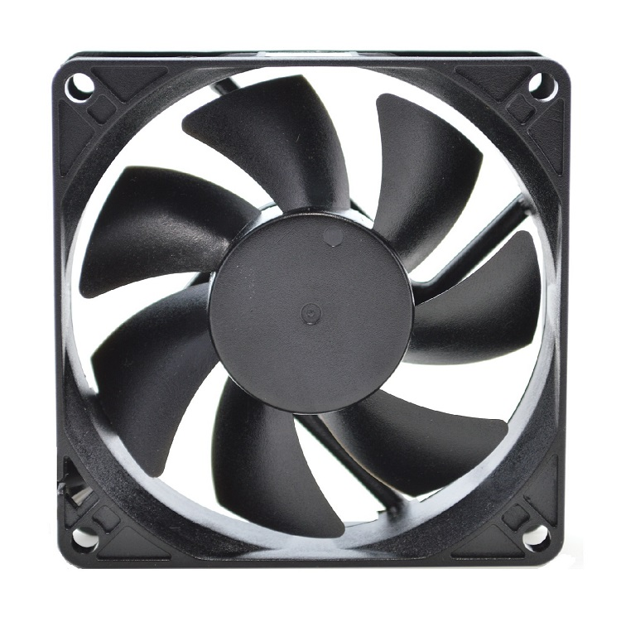

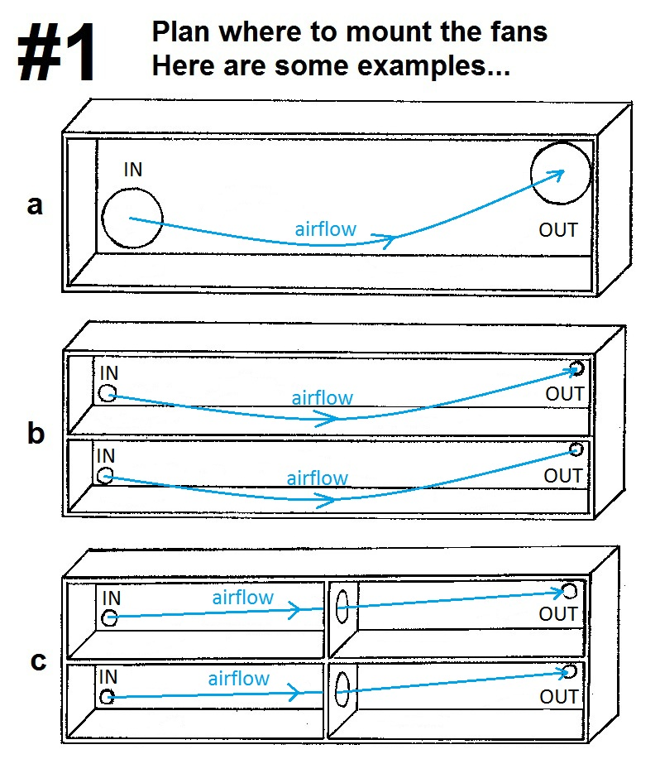

The first thing to do is decide where to mount your new ProCooL AV Cooling System.

The fan location(s) depend on the number of fans you have with your system. Example “**a**” to the right shows a 2 fan system configuration. If your cabinet is fully enclosed typically you would want one fan blowing into the cabinet and the other blowing out to achieve good air circulation.

If the front of your cabinet is open you might consider mounting both fans to blow into the cabinet and onto your hotter components.

You can also directly cool your components as shown in **figure 4** on page 5.

Examples “**b**” and “**c**” show more configurations for cabinets with multiple compartments and for multiple fan systems.

Essentially the fan positions are your choice. Most important is to create air circulation, cool your components and to remove the hot air.

Example “**d**” shows a typical layout for a cabinet with doors enclosing the front. Typically there is a space between the front of the shelf and the inside of the cabinet door. This air space will allow unobstructed airflow from bottom to top. This is the recommended set up for this type of cabinet.

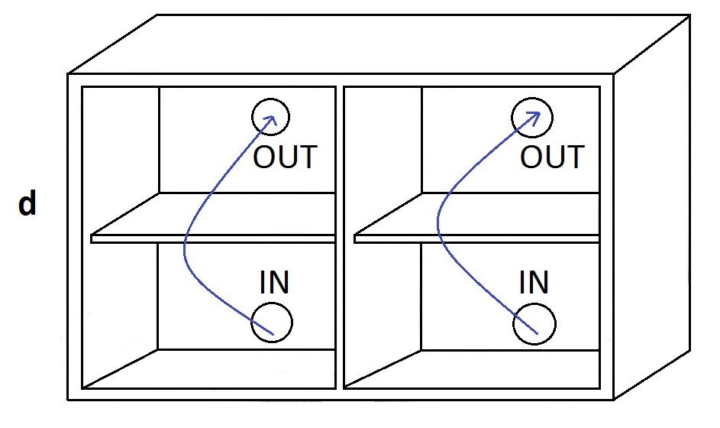

**Mounting the fans**  
The fans can be mounted onto the cabinet or mounting plates can be used.  
Below are instructions and a template for both methods.

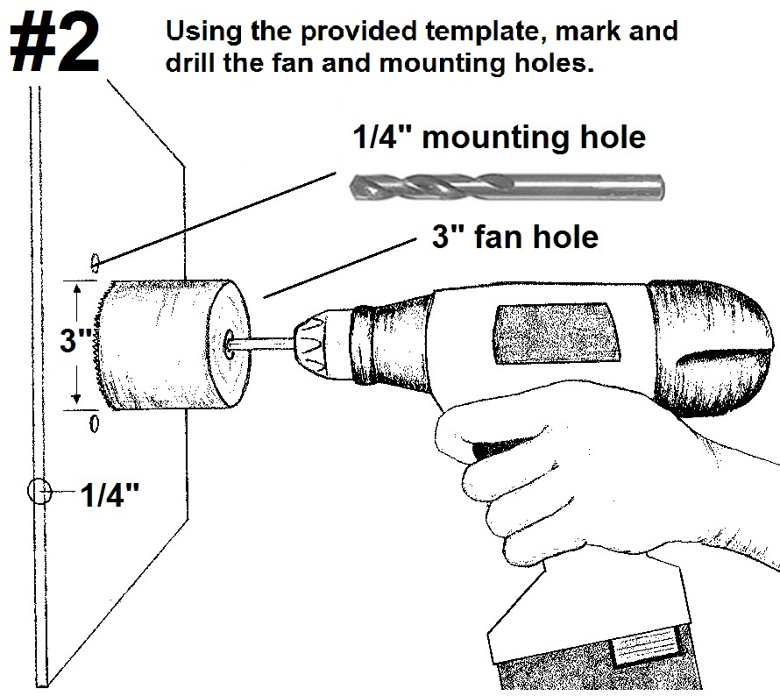

If using mounting plates, Cut out the included template below and tape to the desired location on the cabinet. Using a jigsaw, cut out the center square hole for the fan. If using wood screws to mount the plate to the cabinet, do not drill out the mounting holes for the plate.

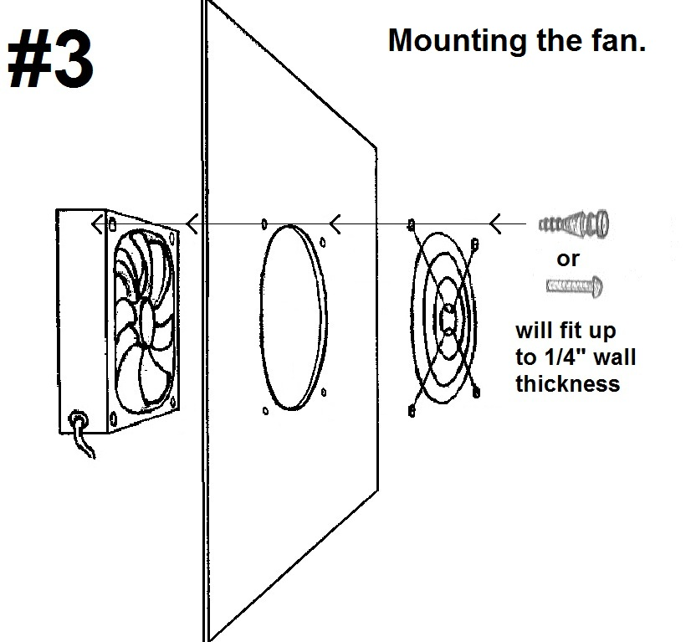

After all of the holes are drilled you can mount the fans. Screws or Silicone rubber soft mounts can be used. If your cabinet wall is thicker you will need to supply longer mounts. Mounting plates shown below are ideal for easy installation in thicker walled cabinets.

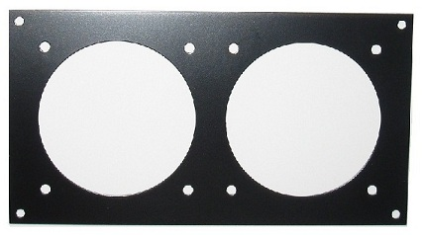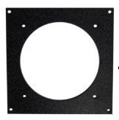

Another solution is to directly cool your components as seen in example #4 below.  
Again like with the cabinets you can choose to blow air in or exhaust out.

Silicone rubber mounts work great as non slip feet. Simply pull them completely through the fans mounting holes. This will also protect the top of your component from scratches. (Sold Seperately)

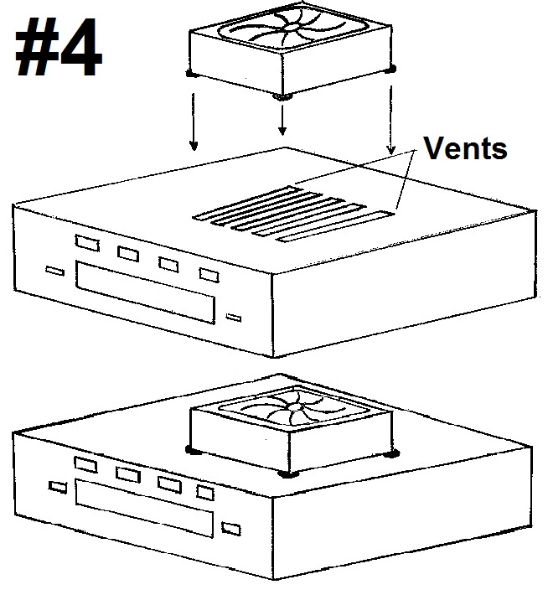

**#5 Connect to the power supply**

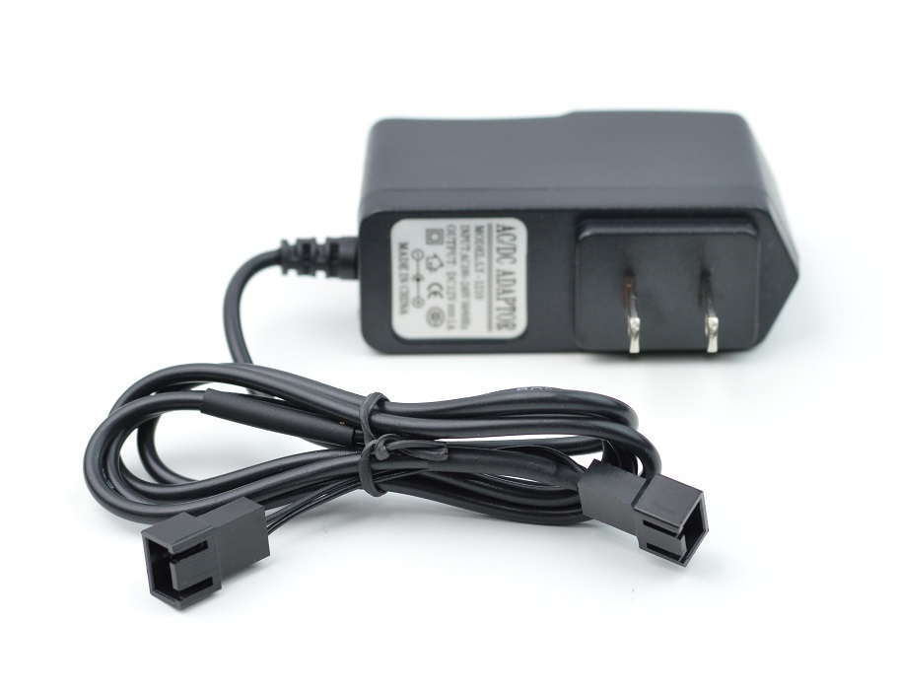

Once the fans are mounted, you can route the wiring to the power supply. The fan power wire length is 24”. Power wire extensions are available at [www.rackfans.com](http://www.rackfans.com) if needed.

*For AVP systems with the fan controller see page 8 for connection instructions.*

The power supply can be plugged into a switched outlet on the back of your receiver. This allows the fans to be shut off with your AV system.

Connect the fans to complete the assembly.

**Positioning the Thermistor probe**

For more precision cooling, locate the thermistor probe near the heat source. You can also locate the probe at the top of the cabinet.

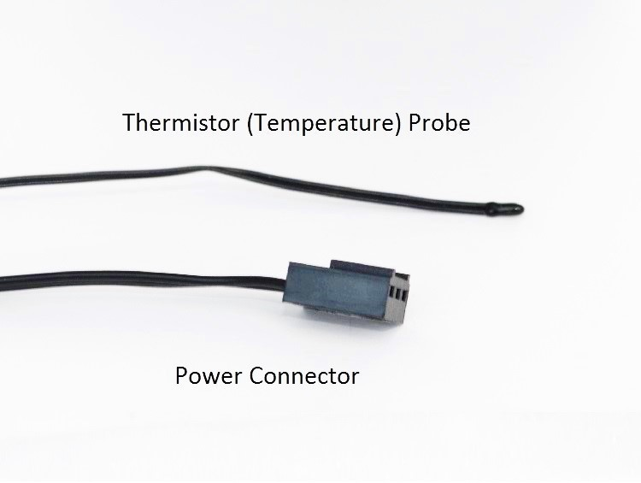

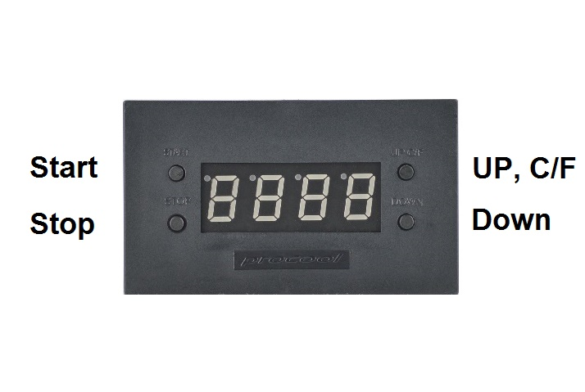**AVP & AVX Systems**

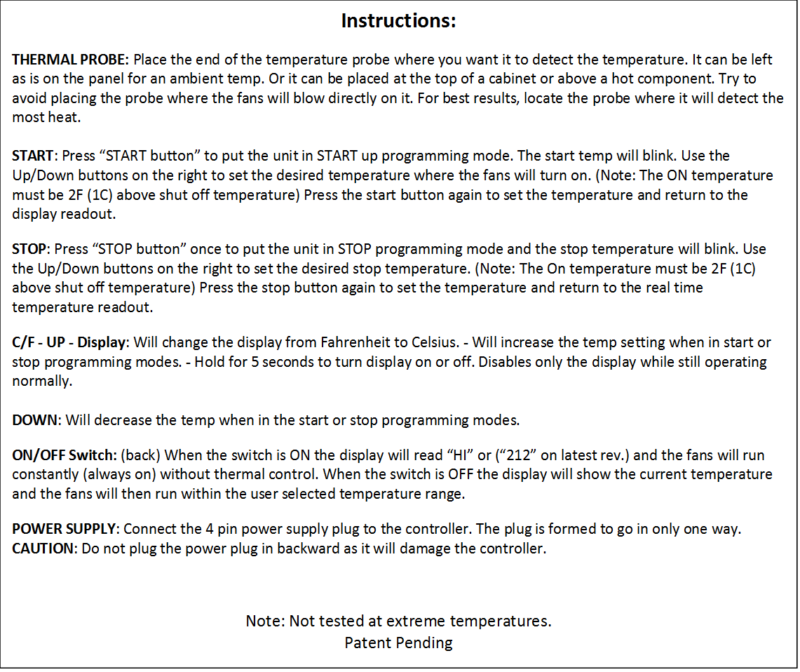

**Multi Fan Controller Connections**

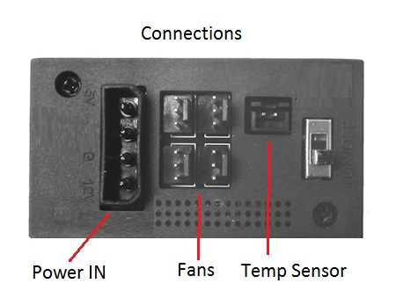

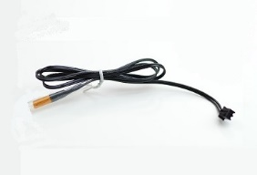

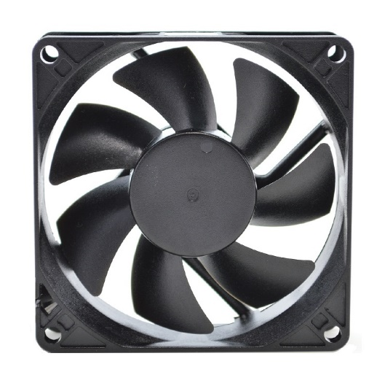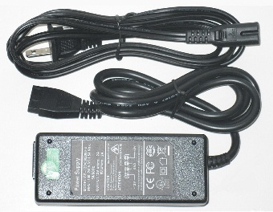

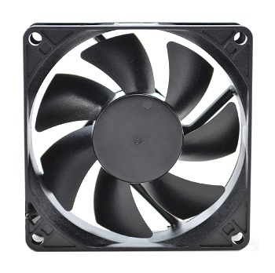**Maintenance**

For best performance, clean the fan blades often. More often if in a dusty environment is better. A can of compressed air works well for frequent cleaning. If dust is visible on the blade it is best to clean it before it builds up. Excess dust/dirt on the fan blades can decrease the fans performance and cause the fan to make noise.   
For more thorough cleaning the blade prop can be removed.  
Grasp the blade prop evenly and pull firmly, straight out of the housing. Use a damp cloth or paper towel to wipe away dust from the blades. Avoid wiping the grease from the shaft.  
The shaft can be lubricated using light grease if needed. Apply a thin layer evenly on the shaft. Re-insert the blade prop into the fan housing. Press in firmly on center of blade prop until it snaps into place. NOTE

***If the fan does not power on, ensure the blade prop is snapped into place. Hard impacts can cause the blade to pop loose and not function. Press IN firmly on the center of the blade prop until it snaps into place. If it does not snap in, pull blade prop out and insert it again. Press until it snaps into place. Once in place the fan will run normally. When the fans are new and if the temp is below 70°F the thermistor probe may need to be warmed by hand slightly to get the fan to spin.***

