***procool***  
AV cooling system   
installation instructions

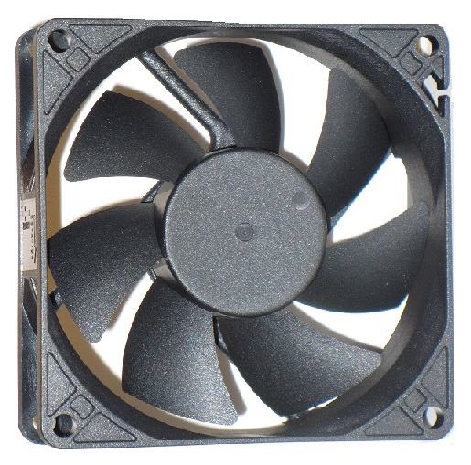

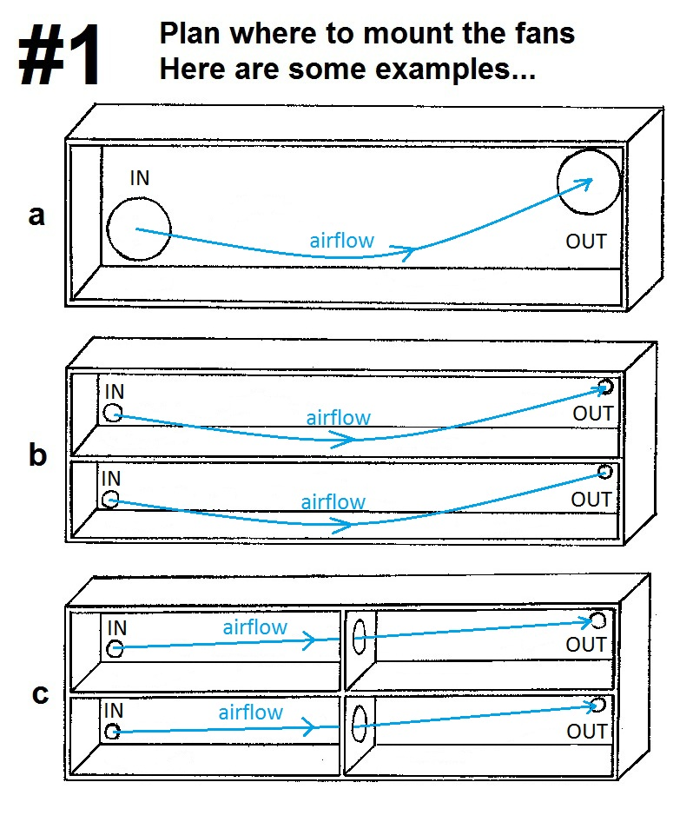

The first thing to do is decide where to mount your new ProCooL AV Cooling System.

The fan location(s) depend on the number of fans you have with your system. Example “**a**” to the right shows a 2 fan system configuration. If your cabinet is fully enclosed typically you would want one fan blowing into the cabinet and the other blowing out to achieve good air circulation.

If the front of your cabinet is open you might consider mounting both fans to blow into the cabinet and onto your hotter components.

You can also directly cool your components as shown in **figure 4** on page 5.

Examples “**b**” and “**c**” show more configurations for cabinets with multiple compartments and for multiple fan systems.

Essentially the fan positions are your choice. Most important is to create air circulation, cool your components and to remove the hot air.

Example “**d**” shows a typical layout for a cabinet with doors enclosing the front. Typically there is a space between the front of the shelf and the inside of the cabinet door. This air space will allow unobstructed airflow from bottom to top. This is the recommended set up for this type of cabinet.

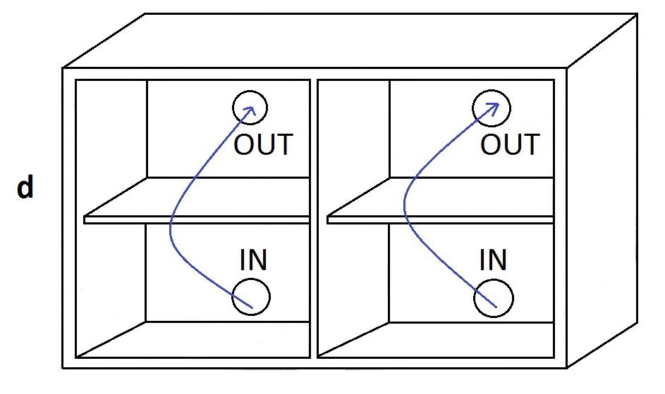

There is sometimes a difference in opinion when deciding to blow air IN or to exhaust air OUT.   
The fact is that it is better to do both in an enclosed or semi enclosed cabinet. You should also consider this within cabinets with multiple compartments.

Consider relocating your components for best control of the heat. Heat rises so naturally the hotter stuff at the top. Blowing air into the lower section and exhausting the air out the top is typically the best method.

You can also directly cool a component by placing the fan directly on it above an existing vent or cooling fin. The fan(s) can be mounted in the cabinet in a position that will blow directly onto a component. This method is best if the cabinet is mostly open.

See our web site for more details. www.rackfans.com

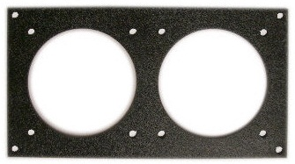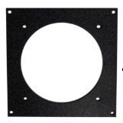

**Mounting the fans**

Shown above are a single and a double fan mounting plate.

Mounting plates can be used to easily mount the fans into most cabinets.  
A good solution for cabinets with thicker walls.

Use a jigsaw to cut out a square hole large enough to fit the fan.  
Use the fan itself as a template to mark a line.   
Once the hole is cut, attach the fan and grill to the mounting plate.  
Insert the assembly into the hole and make any adjustments for alignment.  
Use the mounting plate as a template to mark the mounting holes.  
Attach the plate to the cabinet and connect the fans to the power supply.

See Example #2 for mounting fans without mounting plates.

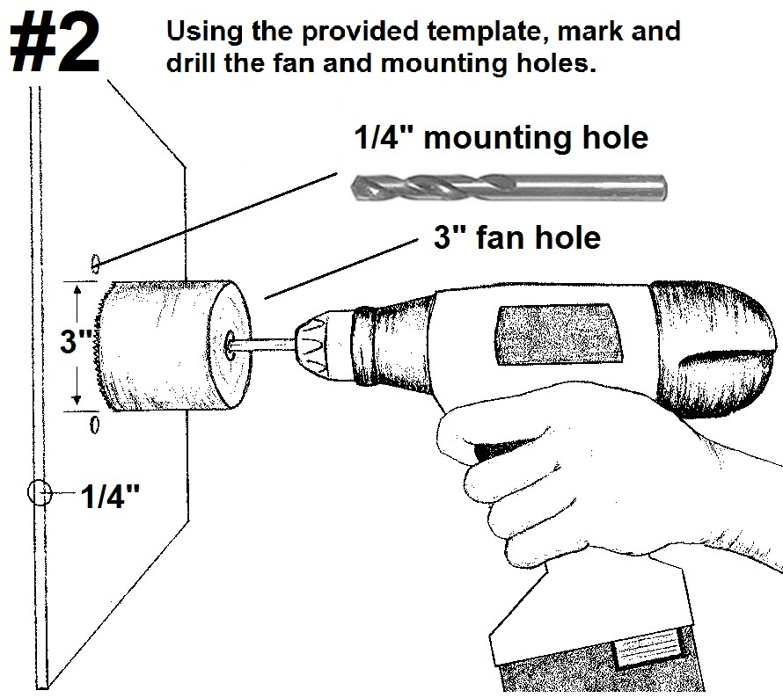

***NOTE:*** *The fan hole size shown above is for the 80mm fans. If you have the 120mm fans the fan hole size should be 4 ¾”. You can use the template or a CD is also the correct fan hole size for a 120mm fan. Both fan sizes use the same ¼” mounting holes.*

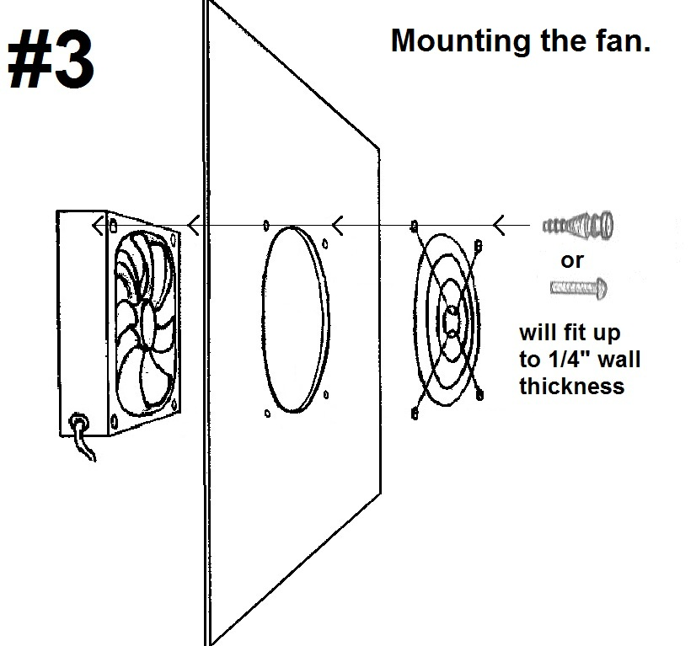

After all of the holes are drilled you can mount the fans. Screws and Silicone rubber soft mounts are included. Both will fit up to ¼” thick cabinet wall. If your cabinet wall is thicker you will need to supply longer mounts. Typically the backs of AV cabinets are not more than ¼” thick. You can also go to [www.rackfans.com](http://www.rackfans.com) and purchase special mounting plates.

Another solution is to directly cool your components as seen in example #4 below.  
Again like with the cabinets you can choose to blow air in or exhaust out.

The Silicone rubber mounts work great as non slip feet. Simply pull them completely through the fans mounting holes. This will also protect the top of your component from scratches.

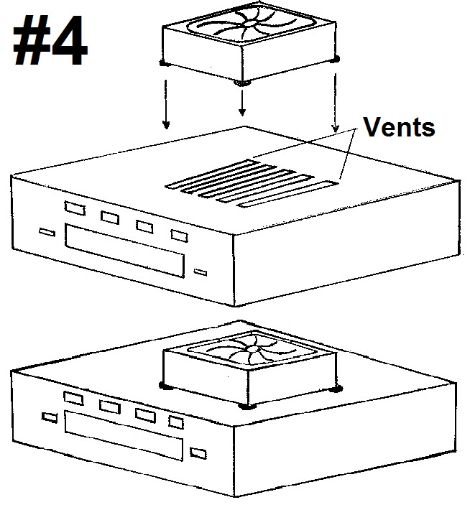

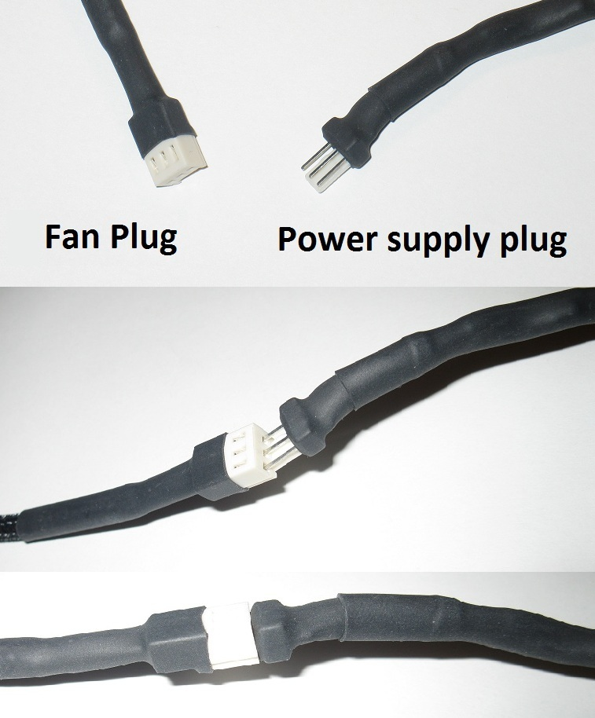**#5 Connect to the power supply**

Once the fans are mounted, you can route the wiring to the power supply. The fan power wire length is 12”. Power wire extensions are available at [www.rackfans.com](http://www.rackfans.com) if needed.

*For AVP systems with the fan controller see page 8 for connection instructions.*

The power supply can be plugged into a switched outlet on the back of your receiver. This allows the fans to be shut off with your AV system.

Connect the fans to complete the assembly.

**Positioning the Thermistor probe**

For more precision cooling, locate the thermistor probe near the heat source. You can also locate the probe at the top of the cabinet.

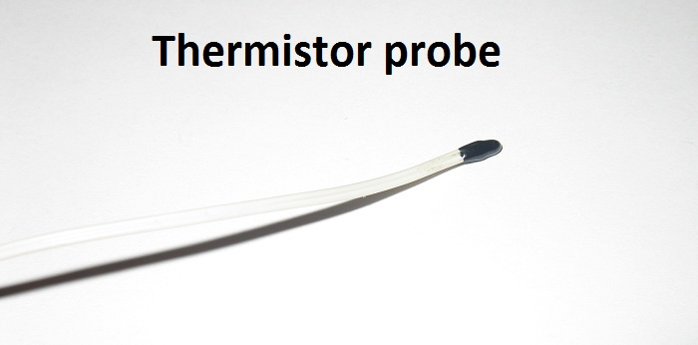

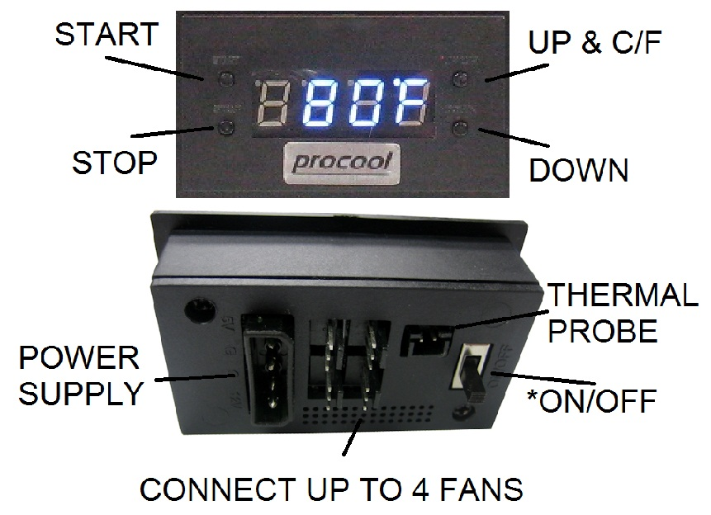**AVP Systems  
Multi Fan Controller Connections**

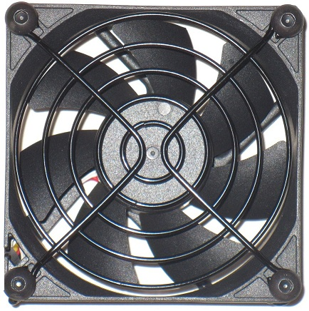

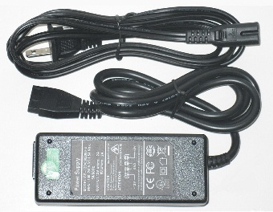

**Maintenance**

For best performance, clean the fan blades often. More often if in a dusty environment is better. A can of compressed air works well for frequent cleaning. If dust is visible on the blade it is best to clean it before it builds up. Excess dust/dirt on the fan blades can decrease the fans performance and cause the fan to make noise.   
For more thorough cleaning the blade prop can be removed.  
Grasp the blade prop evenly and pull firmly, straight out of the housing. Use a damp cloth or paper towel to wipe away dust from the blades. Avoid wiping the grease from the shaft.  
The shaft can be lubricated using light grease if needed. Apply a thin layer evenly on the shaft. Re-insert the blade prop into the fan housing. Press in firmly on center of blade prop until it snaps into place. NOTE

***If the fan does not power on, ensure the blade prop is snapped into place. Hard impacts can cause the blade to pop loose and not function. Press IN firmly on the center of the blade prop until it snaps into place. If it does not snap in, pull blade prop out and insert it again. Press until it snaps into place. Once in place the fan will run normally.***

