**

Model: SXT80, SX80-920, SX80-1124, SX80-1432

MAINTENANCE  
  
regularly clean the fan blades. More often if in a dusty environment. A can of compressed air works well for frequent cleaning. If dust is visible on the blade it is best to clean it before it builds up. Excess dust/dirt on the fan blades can decrease the fans performance and cause the fan to make noise.   
  
For more thorough cleaning the blade prop can be removed.  
Grasp the blade prop evenly and pull firmly, straight out of the housing. Then the blade prop can be cleaned and lubricated.  
The shaft can be lubricated using light grease. Apply a thin layer evenly on the shaft. Re-insert the blade prop into the fan housing. The blade prop will snap into place.

NOTE

If the fan does not power on, ensure the blade prop is snapped into place. Hard impacts can cause the blade to pop loose and not function. Press in firmly on the center of the blade prop.  
Once in place the fan will run normally.

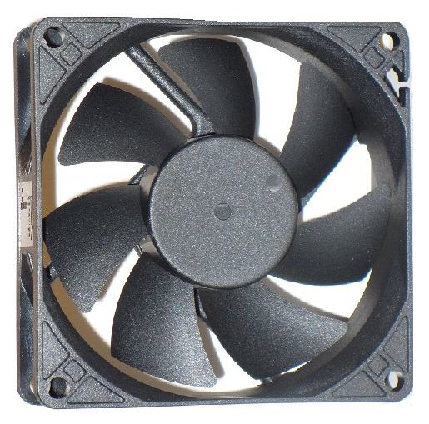

---------------------------------------------------------------------------------------------------------------------------------------------------------------



Model: SXT80, SX80-920, SX80-1124, SX80-1432

MAINTENANCE  
  
regularly clean the fan blades. More often if in a dusty environment. A can of compressed air works well for frequent cleaning. If dust is visible on the blade it is best to clean it before it builds up. Excess dust/dirt on the fan blades can decrease the fans performance and cause the fan to make noise.   
  
For more thorough cleaning the blade prop can be removed.  
Grasp the blade prop evenly and pull firmly, straight out of the housing. Then the blade prop can be cleaned and lubricated.  
The shaft can be lubricated using light grease. Apply a thin layer evenly on the shaft. Re-insert the blade prop into the fan housing. The blade prop will snap into place.

NOTE

If the fan does not power on, ensure the blade prop is snapped into place. Hard impacts can cause the blade to pop loose and not function. Press in firmly on the center of the blade prop.  
Once in place the fan will run normally.