**Features:**  
* 24” thermal probe (48”-72” probes are available separately)  
* 4 3 pin fan connectors  
* 4 pin Molex Power Connector with pass through plug  
* Large LED display (Blue)  
* Option to switch display from Fahrenheit and Celsius.  
* ON/OFF Switches from thermal control to always on  
* Fully programmable from 32-211 degrees F (0-100 Celsius)  
* On temperature must be 2F (1C) above shut off temperature  
* Can handle up to 2A (2,000mA) device current draw

**Dimensions:**   
Device: 71mm x 40mm x 17mm  
Cutout: 68mm x 37mm  
Wall mount plate: 113mm x 82mm  
Shelf mount plate: 93mm x 62mm

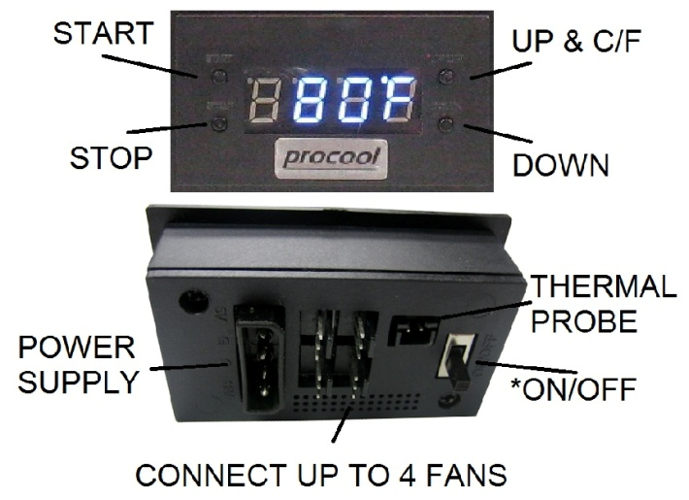

**Instructions:**

**START**: Press the “Start” button to access the programming mode. The display will blink. Use the Up/Down buttons on the right to set the desired “Start” temperature. (Note: The Start temperature must be 2F (1C) above the stop temperature) Press the start button again to set the temperature and return to the current temperature display readout.  
  
**STOP**: Press the “Stop” button once to access the programming mode. The display will blink. Use the Up/Down buttons on the right to set the desired “Stop” temperature. (Note: The Stop temperature must be 2F (1C) below the start temperature) Press the stop button again to set the temperature and return to the current temperature display readout.  
  
**C/F and UP**: Will change the display from Fahrenheit to Celsius or will increase the temp when in start or stop programming modes.

**DOWN**: Will decrease the temp when in the start or stop programming modes.

**THERMAL PROBE:** Locate at top of cabinet or at the heat source for best results.

**ON/OFF Switch** (back) When the switch is ON the display will read “HI” and the fans will run constantly (always on) without thermal control. When the switch is OFF the display will show the temperature and the fans will then run within the selected temperature range.

Note: Not tested at extreme temperatures.   
Patent Pending

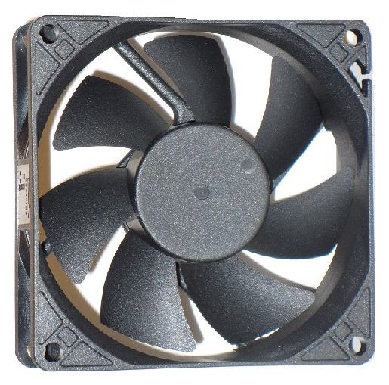Fan Model: SXT80, SX80-920, SX80-1124, SX80-1432  
Systems: AVP-180, AVP-280, AVP-480  
  
For best performance, clean the fan blades often. More often if in a dusty environment is better. A can of compressed air works well for frequent cleaning. If dust is visible on the blade it is best to clean it before it builds up. Excess dust/dirt on the fan blades can decrease the fans performance and cause the fan to make noise.   
For more thorough cleaning the blade prop can be removed.  
Grasp the blade prop evenly and pull firmly, straight out of the housing. Use a damp cloth or paper towel to wipe away dust from the blades. Avoid wiping the grease from the shaft.  
The shaft can be lubricated using light grease if needed. Apply a thin layer evenly on the shaft. Re-insert the blade prop into the fan housing. Press in firmly on center of blade prop until it snaps into place.

BLADE PROP

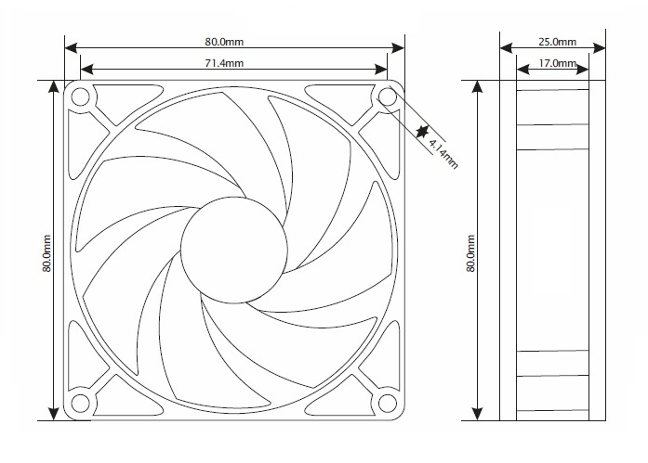***If the fan does not power on, ensure the blade prop is snapped into place. Hard impacts can cause the blade to pop loose and not function. Press IN firmly on the center of the blade prop until it snaps into place. If it does not snap in, pull blade prop out and insert it again. Press until it snaps into place. Once in place the fan will run normally.***

|  |  |  |  |
| --- | --- | --- | --- |
| Fan Model SXT80 Specifications | | | |
| Rated Voltage | | 12.0 vDC | |
| Voltage Range | | 11.0~14.0 vDC | |
| Rated Current | | 0.17 A | |
| Rated Power | | 2.04 w | |
| Rated Speed | | <1000-1700 RPM | |
| Airflow | | <14-32 CFM | |
| Static Pressure | | <2.89 mm H²O | |
| Noise Level, 1m, xyz axes avg | | <6-14 dBA | |
| Noise Level, 1m, z axis | | <6-17 dBA | |
| Operating Temperature | | -10°/+70° C | |
| Storage Temperature | | -40°/+80° C | |
| Bearing | | Fluid Dynamic | |
| Weight | | 2.8 oz | |
| MTBF Hours | | | |
| Temperature | L50 | | L10 |
| 30° C | 294293 | | 126982 |
| 40° C | 203982 | | 88015 |
| 50° C | 144631 | | 62406 |
| 60° C | 104689 | | 45171 |
| 70° C | 77219 | | 33319 |