ProCooL_LOGO 3.jpg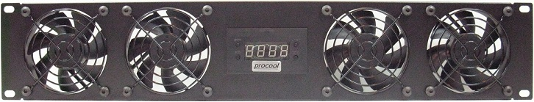ProCooL_LOGO 3.jpg

\* Model No. **SP480X, SP480X-E**

|  |  |
| --- | --- |
| Panel SIze: | (2U) 19" x 3.5" x 1.5" |
| Panel Color/Material: | Black/Metal |
| Fans: | 4 |
| Fan Size: | 80mm x 80mm x 25mm |
| Fan Speed: | 1800 RPM |
| Air Flow: | 128 CFM |
| Noise: | 20 dBA |
| Bearings: | fluid dynamic bearings |
| Thermal Probe length | 24" (48", 72” available) |
| Power Supply: | 100-240 VAC/12VDC/5VDC |
| Power Supply Cable length | AC-60" DC-36" |
| Current draw: | .64A |
| Power consumption: | 7.68w |
| Grills/Guards: | Black Wire |

**Temp Controller Features:**  
\* 24” thermal probe (48”-72” probes are available separately)  
\* 4 3 pin fan connectors  
\* 4 pin Molex Power Connector  
\* Large LED display (Blue)  
\* Option to switch display from Fahrenheit and Celsius.  
\* ON/OFF Switches from thermal control to always on  
\* Fully programmable from 32-211 degrees F (0-100 Celsius)  
\* On temperature must be 2F (1C) above shut off temperature  
\* Can handle up to 2A (2,000mA) device current draw

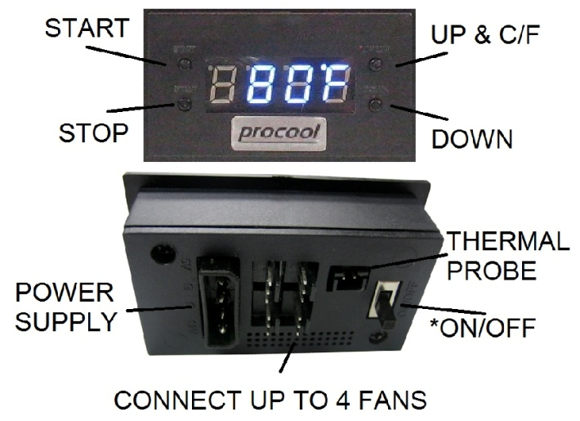

**Instructions:**

**THERMAL PROBE:** Place the end of the temperature probe where you want it to detect the temperature. It can be left as is on the panel for an ambient temp. Or it can be placed at the top of a cabinet or above a hot component. Try to avoid placing the probe where the fans will blow directly on it. For best results, locate the probe where it will detect the most heat.  
**START**: Press “START button” to put the unit in START up programming mode. The start temp will blink. Use the Up/Down buttons on the right to set the desired temperature where the fans will turn on. (Note: The ON temperature must be 2F (1C) above shut off temperature) Press the start button again to set the temperature and return to the display readout.

**STOP**: Press “STOP button” once to put the unit in STOP programming mode and the stop temperature will blink. Use the Up/Down buttons on the right to set the desired stop temperature. (Note: The On temperature must be 2F (1C) above shut off temperature) Press the stop button again to set the temperature and return to the real time temperature readout.

**C/F or UP**: Will change the display from Fahrenheit to Celsius or will increase the temp when in start or stop programming modes.  
  
**DOWN**: Will decrease the temp when in the start or stop programming modes.

**ON/OFF Switch** (back) When the switch is ON the display will read “HI” and the fans will run constantly (always on) without thermal control. When the switch is OFF the display will show the temperature and the fans will then run within the user selected temperature range.

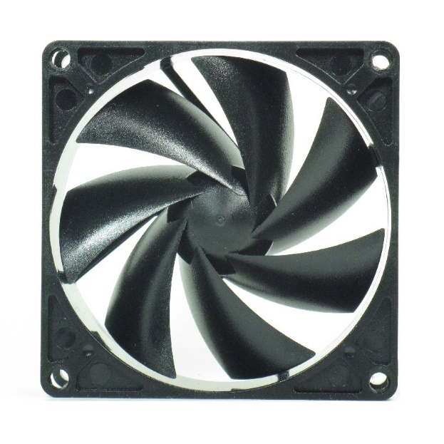For best performance, clean the fan blades often. More often if in a dusty environment is better. A can of compressed air works well for frequent cleaning. If dust is visible on the blade it is best to clean it before it builds up. Excess dust/dirt on the fan blades can decrease the fans performance and cause the fan to make noise.

For more thorough cleaning the blade prop can be removed. Grasp the blade prop evenly and pull firmly, straight out of the housing. Use a damp cloth or paper towel to wipe away dust from the blades. Avoid wiping the grease from the shaft. The shaft can be lubricated using light grease if needed. Apply a thin layer evenly on the shaft. Re-insert the blade prop into the fan housing. Press in firmly on center of blade prop until it snaps into place.

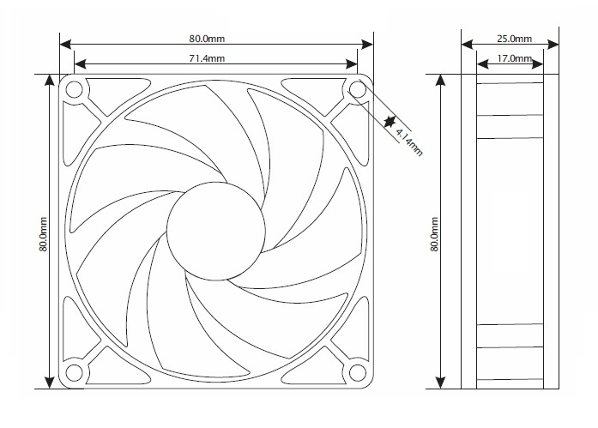

***If a fan is not spinning***

*Ensure the blade prop is snapped into place. Hard impacts can cause the blade to pop loose and not function.*

*Press IN firmly on the center of the blade prop until it snaps into place. Use a small screwdriver or similar that will fit through the front grill.*

*If it does not snap in, remove the grill guard, pull the blade prop out and insert it again. Press in firmly until it snaps into place. Once in place the fan will run normally.*