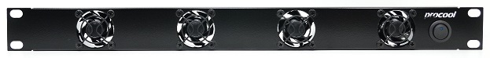

**The Procool TURBO VENT provides high volume airflow in a 1U format.   
Mounts in a standard 19” rack.**

|  |  |
| --- | --- |
| ProCooL_LOGO 3.jpg**Model No. TV440** | |
| Panel Size: | (2U) 19" x 3.5" x 2.0" |
| Panel color/material: | black/metal |
| Fans: | 4 |
| Fan Size: | 40mm x 40mm x 20mm |
| Fan Speed: | 6000 RPM |
| Air Flow: | 28 CFM |
| Noise: | 32 dBA |
| Bearings: | Dual ball bearings |
| Fan thermistor wire length | n/a |
| Controller Thermal Probe length | n/a |
| Power Supply: | 100-240 VAC - 12 VDC |
| Power Supply Cable length | 36" |
| Power Supply Plug Type: | NEMA 1-15/ IEC-C7 |
| Current draw: | 0.24A |
| Power consumption: | 2.88w |
| Grills/Guards: | Black Wire |

* High Airflow
* 1 rack space
* Front panel On/Off Switch
* Easy mount slots
* 2 Year limited warranty

4 industrial quality 40mm fans are durable and suitable for extreme cooling needs.

