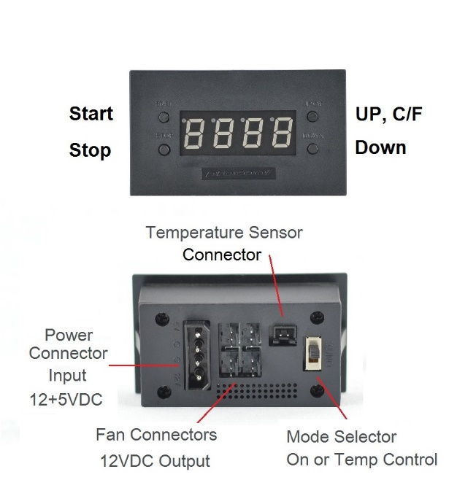

**Features:**  
* Connect up to 4 fans  
* Large Blue LED display (Switchable- on or off)  
* Switch between Fahrenheit and Celsius easily.  
* ON/OFF (back) Switches from thermal control to always on  
* Programmable from 32-212°F (0-100 Celsius)  
* 24” thermal probe (48” Extensions are available separately)

**Dimensions:**   
Device: 71mm x 40mm x 17mm  
Cutout: 68mm x 37mm  
Wall mount plate: 113mm x 82mm  
Shelf mount plate: 93mm x 62mm

**Instructions:**

**THERMAL PROBE:** Place the end of the temperature probe where you want it to detect the temperature. It can be left as is on the panel for an ambient temp. Or it can be placed at the top of a cabinet or above a hot component. Try to avoid placing the probe where the fans will blow directly on it. For best results, locate the probe where it will detect the most heat.  
**START**: Press “START button” to put the unit in START up programming mode. The start temp will blink. Use the Up/Down buttons on the right to set the desired temperature where the fans will turn on. (Note: The ON temperature must be 2F (1C) above shut off temperature) Press the start button again to set the temperature and return to the display readout.

**STOP**: Press “STOP button” once to put the unit in STOP programming mode and the stop temperature will blink. Use the Up/Down buttons on the right to set the desired stop temperature. (Note: The On temperature must be 2F (1C) above shut off temperature) Press the stop button again to set the temperature and return to the real time temperature readout.

**C/F - UP - Display**: Will change the display from Fahrenheit to Celsius. **-** Will increase the temp setting when in start or stop programming modes. **-** Hold for 5 seconds to turn display on or off. Disables only the display while still operating normally.  
  
**DOWN**: Will decrease the temp when in the start or stop programming modes.

**ON/OFF Switch:** (back) When the switch is ON the display will read “HI” or (“212” on latest rev.) and the fans will run constantly (always on) without thermal control. When the switch is OFF the display will show the current temperature and the fans will then run within the user selected temperature range.

**POWER SUPPLY**: Connect the 4 pin power supply plug to the controller. The plug is formed to go in only one way. **CAUTION**: Do not plug the power plug in backward as it will damage the controller.

Note: Not tested at extreme temperatures.   
Patent Pending

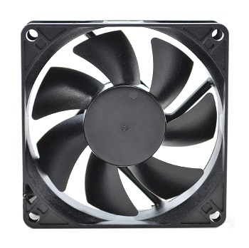All Procool Cabinet Fan systems include model **SXT80** fans. These extremely quiet variable speed fans provide up to 32 CFM each with only 14 dBA of noise. A thermistor probe controls the speed from low to high speed. When the probe is cool the fan runs slow. At about 80°F the speed begins to increase. Full speed is reached at about 95°F.  
  
For best performance, clean the fan blades often. More often if in a dusty environment is better. A can of compressed air works well for frequent cleaning. If dust is visible on the blade it is best to clean it before it builds up. Excess dust/dirt on the fan blades can decrease the fans performance and cause the fan to make noise.   
For more thorough cleaning the blade prop can be removed.  
Grasp the blade prop evenly and pull firmly, straight out of the housing. Use a damp cloth or paper towel to wipe away dust from the blades. Avoid wiping the grease from the shaft.  
The shaft can be lubricated using light grease if needed. Apply a thin layer evenly on the shaft. Re-insert the blade prop into the fan housing. Press in firmly on center of blade prop until it snaps into place. BLADE PROP

***If the fan does not power on, ensure the blade prop is snapped into place. Hard impacts can cause the blade to pop loose and not function. Press IN firmly on the center of the blade prop until it snaps into place. If it does not snap in, pull blade prop out and insert it again. Press until it snaps into place. Once in place the fan will run normally. When the fans are new and if the temp is below 70°F the thermistor probe may need to be warmed by hand slightly to get the fan to spin.***

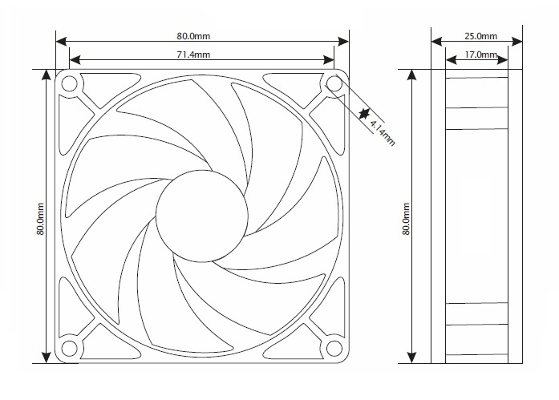

|  |  |  |  |
| --- | --- | --- | --- |
| Fan Model SXT80 Specifications | | | |
| Rated Voltage | | 12.0 VDC | |
| Voltage Range | | 11.0~14.0 VDC | |
| Rated Current | | 0.17 A | |
| Rated Power | | 2.04 w | |
| Rated Speed | | <1200-2400 RPM | |
| Airflow | | <14-32 CFM | |
| Static Pressure | | <2.89 mm H²O | |
| Noise Level, 1m, xyz axes avg | | <6-14 dBA | |
| Noise Level, 1m, z axis | | <6-17 dBA | |
| Operating Temperature | | -10°/+70° C | |
| Storage Temperature | | -40°/+80° C | |
| Bearing | | Fluid Dynamic | |
| Weight | | 2.8 oz | |
| MTBF Hours | | | |
| Temperature | L50 | | L10 |
| 30° C | 294293 | | 126982 |
| 40° C | 203982 | | 88015 |
| 50° C | 144631 | | 62406 |
| 60° C | 104689 | | 45171 |
| 70° C | 77219 | | 33319 |