ProCooL_LOGO 3.jpg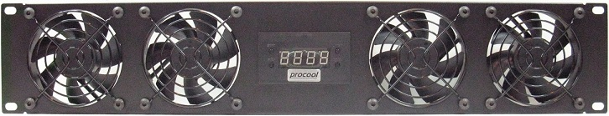ProCooL_LOGO 3.jpg

\* Model No. **SP480C (Blue LED Fans)**

|  |  |
| --- | --- |
| Panel SIze: | (2U) 19" x 3.5" x 1.5" |
| Panel Color/Material: | Black/Metal |
| Fans: | 4 Blue LED fans |
| Fan Size: | 80mm x 80mm x 25mm |
| Thermal Probe length | 24" (48", 72” available) |
| Power Supply: | 100-240 VAC/12VDC/5VDC |
| Power Supply Cable length | AC-60" DC-36" |
| Current draw: | .64A |
| Power consumption: | 7.68w |
| Grills/Guards: | Black Wire |

**Temp Controller Features:**  
\* 24” thermal probe (48”-72” probes are available separately)  
\* 4 3 pin fan connectors  
\* 4 pin Molex Power Connector  
\* Large LED display (Blue)  
\* Option to switch display from Fahrenheit and Celsius.  
\* ON/OFF Switches from thermal control to always on  
\* Fully programmable from 32-211 degrees F (0-100 Celsius)  
\* On temperature must be 2F (1C) above shut off temperature  
\* Can handle up to 2A (2,000mA) device current draw

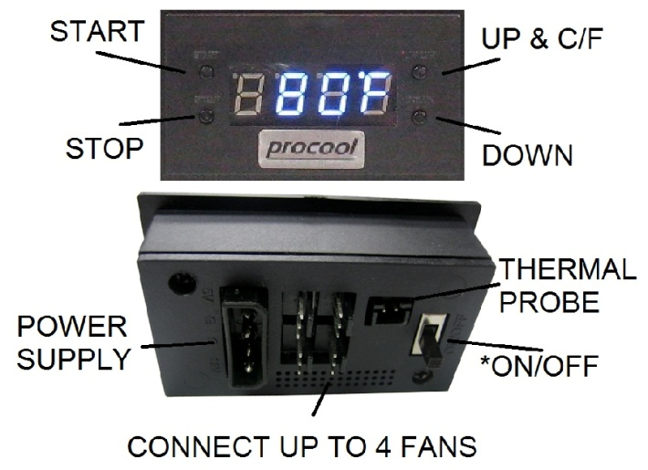

**Instructions:**

**THERMAL PROBE:** Place the end of the temperature probe where you want it to detect the temperature. It can be left as is on the panel for an ambient temp. Or it can be placed at the top of a cabinet or above a hot component. Try to avoid placing the probe where the fans will blow directly on it. For best results, locate the probe where it will detect the most heat.  
**START**: Press “START button” to put the unit in START up programming mode. The start temp will blink. Use the Up/Down buttons on the right to set the desired temperature where the fans will turn on. (Note: The ON temperature must be 2F (1C) above shut off temperature) Press the start button again to set the temperature and return to the display readout.

**STOP**: Press “STOP button” once to put the unit in STOP programming mode and the stop temperature will blink. Use the Up/Down buttons on the right to set the desired stop temperature. (Note: The On temperature must be 2F (1C) above shut off temperature) Press the stop button again to set the temperature and return to the real time temperature readout.

**C/F or UP**: Will change the display from Fahrenheit to Celsius or will increase the temp when in start or stop programming modes.  
  
**DOWN**: Will decrease the temp when in the start or stop programming modes.

**ON/OFF Switch** (back) When the switch is ON the display will read “HI” and the fans will run constantly (always on) without thermal control. When the switch is OFF the display will show the temperature and the fans will then run within the user selected temperature range.