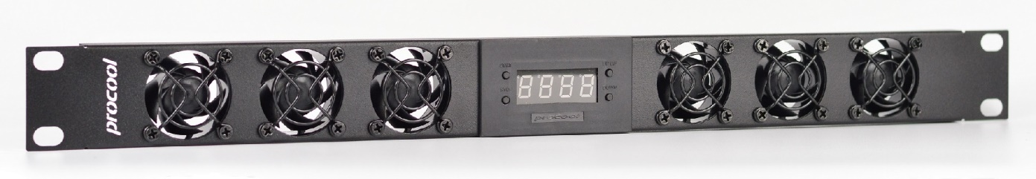

**Instructions:**

**THERMAL PROBE:** Place the end of the temperature probe where you want it to detect the temperature. It can be left as is on the panel for an ambient temp. Or it can be placed at the top of a cabinet or above a hot component. Try to avoid placing the probe where the fans will blow directly on it. For best results, locate the probe where it will detect the most heat.  
**START**: Press “START button” to put the unit in START up programming mode. The start temp will blink. Use the Up/Down buttons on the right to set the desired temperature where the fans will turn on. (Note: The ON temperature must be 2F (1C) above shut off temperature) Press the start button again to set the temperature and return to the display readout.

**STOP**: Press “STOP button” once to put the unit in STOP programming mode and the stop temperature will blink. Use the Up/Down buttons on the right to set the desired stop temperature. (Note: The On temperature must be 2F (1C) above shut off temperature) Press the stop button again to set the temperature and return to the real time temperature readout.

**C/F - UP - Display**: Will change the display from Fahrenheit to Celsius. **-** Will increase the temp setting when in start or stop programming modes. **-** Hold for 5 seconds to turn display on or off. Disables only the display while still operating normally.  
  
**DOWN**: Will decrease the temp when in the start or stop programming modes.

**ON/OFF Switch** (back) When the switch is ON the display will read “HI” or (“212” on latest rev.) and the fans will run constantly (always on) without thermal control. When the switch is OFF the display will show the current temperature and the fans will then run within the user selected temperature range.

**POWER SUPPLY**: Connect the 4 pin power supply plug to the controller. The plug is formed to go in only one way. **CAUTION**: Do not plug the power plug in backward as it will damage the controller.

\* Model No. **SP640X & SP640TV** (Intake models) **SP640X-E, SP640TV-E** (Exhaust models)

**Temperature Display/ Fan Controller Features:**  
\* Connect up to 4 fans

\* Large Blue LED display (Switchable- on or off)

\* Switch between Fahrenheit or Celsius easily.

\* ON/OFF (back) Switches from thermal control to always on.

\* Programmable from 32-212°F (0-100 Celsius)

\* 24” thermal probe (48” Extensions are available separately)

ProCooL_LOGO 3.jpg

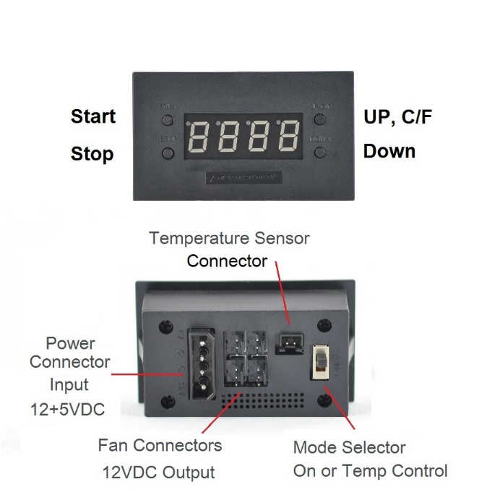

|  |  |
| --- | --- |
| **Model No. SP640X & SP640X-E** | |
| Panel Size: | (1U) 19" x 1.75" x 2.0" |
| Panel color/material: | black/metal |
| Fans: | 6 |
| Fan Size: | 40mm x 40mm x 20mm |
| Fan Speed: | 3200 RPM |
| Air Flow: | 36 CFM |
| Noise: | 21.77 dBA |
| Bearings: | Fluid Dynamic bearings |
| Fan thermistor wire length | n/a |
| Controller Thermal Probe length | 24" (48" extensions available) |
| Power Supply: | 100-240 VAC - 12 VDC/5VDC |
| Power Supply Cable length | AC-60" DC-36" |
| Power Supply Plug Type: | NEMA 1-15/ IEC-C7 |
| Current draw: | 0.18A |
| Power consumption: | 2.16w |
| MTBF Hours | 49,925 |
| Grills/Guards: | Black Wire |

|  |  |
| --- | --- |
| **Model No. SP640TV & SP640TV-E** | |
| Panel Size: | (1U) 19" x 1.75" x 2.0" |
| Panel color/material: | black/metal |
| Fans: | 6 |
| Fan Size: | 40mm x 40mm x 20mm |
| Fan Speed: | 6000 RPM |
| Air Flow: | 42.6 CFM |
| Noise: | 33.8 dBA |
| Bearings: | Dual ball bearings |
| Fan thermistor wire length | n/a |
| Controller Thermal Probe length | 24" (48" extensions available) |
| Power Supply: | 100-240 VAC - 12 VDC/5VDC |
| Power Supply Cable length | AC-60" DC-36" |
| Power Supply Plug Type: | NEMA 1-15/ IEC-C7 |
| Current draw: | 0.36A |
| Power consumption: | 4.32w |
| MTBF Hours | 50,000 |
| Grills/Guards: | Black Wire |

