**PROCOOL SX80 FAN SERIES RACK MOUNT COOLING SYSTEMS**

*Intake Models: SX280, SX380, SX480, SX2280, SP280X and SP480X*

*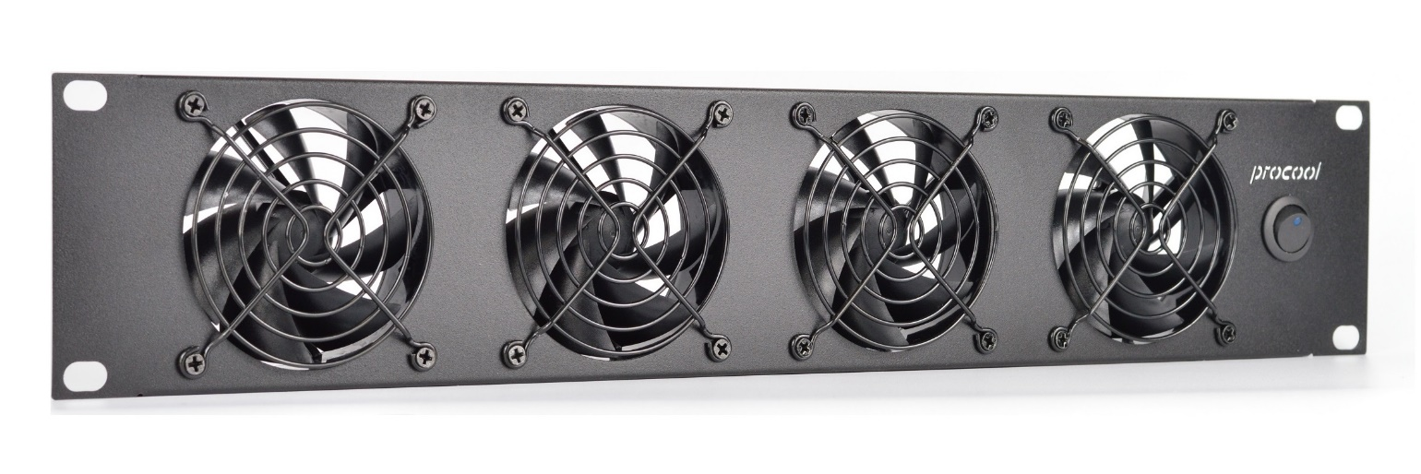Exhaust Models: SX280-E, SX380-E, SX480-E, SX2280-E, SP280X-E and SP480X-E*

|  |  |  |  |  |
| --- | --- | --- | --- | --- |
| **Model No.** | **SX280, SX280-E, *SP280X, SP280X-E** | **SX380, SX380-E** | **SX480, SX480-E** | **SX2280, SX2280-E *SP480X, SP480X-E** |
| Panel Size: | 2U (19"w x 3.5"h x 1.75”d) | 2U (19"w x 3.5"h x 1.75”d) | 2U (19"w x 3.5"h x 1.75”d) | 2U (19"w x 3.5"h x 1.75”d) |
| Panel color/material: | Black/metal | Black/metal | Black/metal | Black/metal |
| Fan Size: | 80mm x 80mm x 25mm | 80mm x 80mm x 25mm | 80mm x 80mm x 25mm | 80mm x 80mm x 25mm |
| Number of Fans: | 2 | 3 | 4 | 4 |
| Fan Speed (per fan): | 1600 RPM | 1600 RPM | 1600 RPM | 1600 RPM |
| Air Flow Direction | INTAKE (*E = EXHAUST) | INTAKE (*E = EXHAUST) | INTAKE (*E = EXHAUST) | INTAKE (*E = EXHAUST) |
| Air Flow (combined): | 64 CFM | 96 CFM | 128 CFM | 128 CFM |
| Static Pressure (per fan): | 2.89mm H²O | 2.89mm H²O | 2.89mm H²O | 2.89mm H²O |
| Noise (combined): | 17 dBA | 19 dBA | 20 dBA | 20 dBA |
| Thermistor Probe length | 24” | 24” | 24” | 24” |
| Grills/Guards: | Black Wire | Black Wire | Black Wire | Black Wire |
| Bearings: | Fluid Dynamic | Fluid Dynamic | Fluid Dynamic | Fluid Dynamic |
| Power Supply: | 100-240 VAC - 12 VDC | 100-240 VAC - 12 VDC | 100-240 VAC - 12 VDC | 100-240 VAC - 12 VDC |
| Power Supply Plug: | NEMA 1-15 – 2.1mm | NEMA 1-15 – 2.1mm | NEMA 1-15 – 2.1mm | NEMA 1-15 – 2.1mm |
| Power Supply Cable: | 36" | 36" | 36" | 36" |
| Current draw: | 0.18A | 0.27A | 0.36A | 0.36A |
| Power consumption: | 2.16w | 3.24w | 4.32w | 4.32w |
| Weight | 2 lbs. | 2 lbs. | 2 lbs. | 2 lbs. |
| Operating Temperature | -10°/+70° C | -10°/+70° C | -10°/+70° C | -10°/+70° C |
| Storage Temperature | -40°/+80° C | -40°/+80° C | -40°/+80° C | -40°/+80° C |
|  |  |  |  |  |
|  |  |  |  |  |

* Specifications are subject to change without notice.

**Model SX80 Silent Fan**The SX80 series of fans provide the quietest cooling solution. Recommended where absolutely silent cooling is required. The SX80 fans provide 32 CFM of airflow while running at a whisper quiet 14 dBA. The special blade design creates more airflow with less noise than conventional ball bearing type fans.

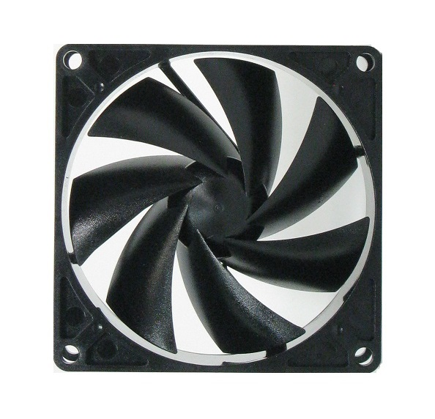

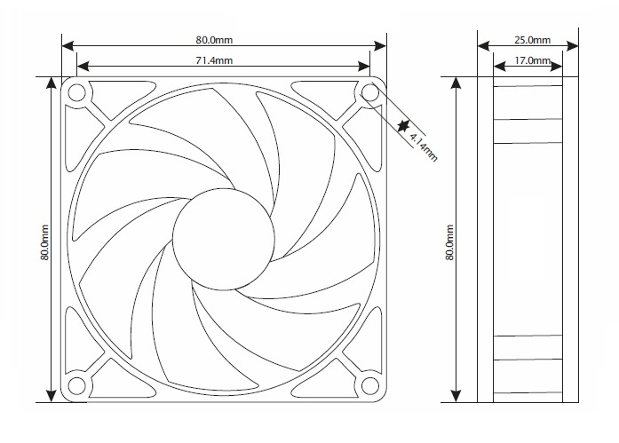

|  |  |
| --- | --- |
| SXT80 Specifications | |
| Rated Voltage | 12.0 vDC |
| Voltage Range | 10.2~13.8 vDC |
| Rated Current | 0.17 A |
| Rated Power | 2.04 w |
| Rated Speed | <1600 RPM |
| Airflow | <32 CFM |
| Static Pressure | <2.89 mm H²O |
| Noise Level, 1m, xyz axes avg | <14 dBA |
| Noise Level, 1m, z axis | <17 dBA |
| Operating Temperature | -10°/+70° C |
| Storage Temperature | -40°/+80° C |
| Bearing | Fluid Dynamic |
| Weight | 2.8 oz. |

Pressure Curve

|  |  |  |
| --- | --- | --- |
| MTBF Hours | | |
| Temperature | L50 | L10 |
| 30° C | 294293 | 114223 |
| 40° C | 203982 | 64072 |
| 50° C | 144631 | 37224 |
| 60° C | 104689 | 22336 |
| 70° C | 77219 | 14012 |

**RoHS Certificate of Compliance:**

As of February 2, 2006

This “RoHS Certificate” provides information regarding the absence of certain substances in the Fan model listed on this document.

The models identified below are in compliance with the European Union

Directive 2002/95/EC on the restriction of use of certain hazardous

substances (“RoHS Directive”). The models do not contain any of the restricted

substances referred to in the European Union Commission Decision of August18, 2006 (2005/618/EC) in connection with Articles 4 and 5 of the RoHS

Directive in concentrations in excess of the values permitted thereunder.

For purposes of this RoHS Certificate, the maximum concentration values of the restricted substances by weight of homogeneous materials are:

hexavalent chromium 1,000 ppm

poly-brominated biphenyls (PBB's) 1,000 ppm

poly-brominated diphenyl ethers (PBDE's) 1,000 ppm

cadmium 100 ppm

mercury 1,000 ppm

lead 1,000 ppm

Conforms to CE - Reference 73/23/EEC Low Voltage Directive.

Fan housing and fan blade resin flammability conforms to class UL-94V-2.

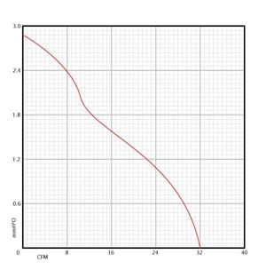

**Operation:**

Mount in desired location for optimal cooling. Intakes are best positioned lower or adjacent to equipment.  
Exhausts are best positioned at the top or above equipment. Connect power.

**Maintenance:**

Cleaning the fan is the best preventative maintenance. Cleaning frequency would depend on the environment. It is recommended that the blade be cleaned to prevent any buildup of dust. Canned air works well.

*Blade Removal:*

For cleaning and maintenance, the blade prop can be removed.

Grasp the blade prop and pull straight out of the fan body. Inspect the shaft and lubricate if needed. Any oil will work; light grease works best. Clean blade as needed with a dry cloth. Soap and water can be used if needed, but should be thoroughly rinsed and dried before use. Reinstall the blade; when properly installed the blade will snap into place. Cleaning and inspection of the blade shaft should be done annually for best performance.

**Warranty:**

2 Years from the date of purchase.