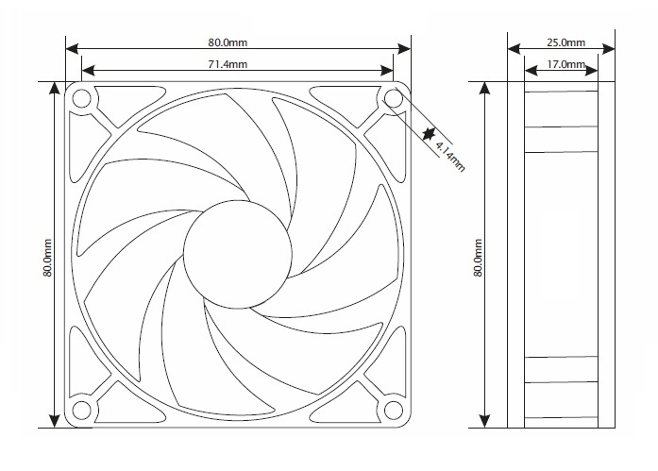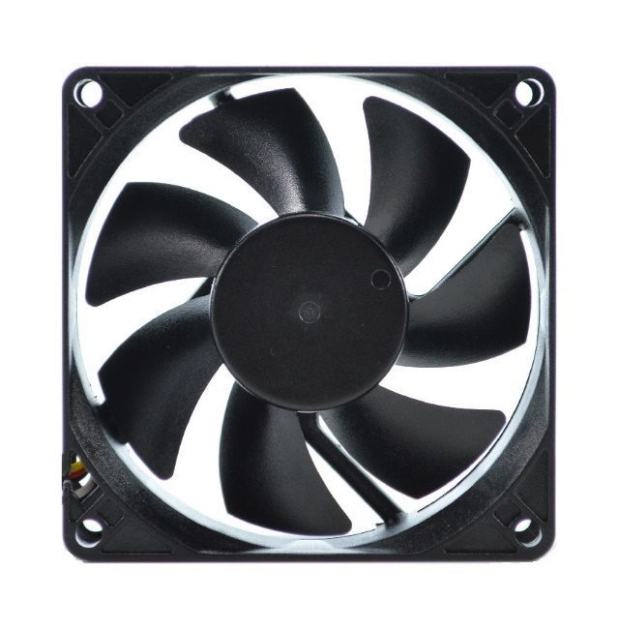

|  |  |
| --- | --- |
| Specifications | |
| Rated Voltage | 12.0 vDC |
| Voltage Range | 10.2~13.8 vDC |
| Rated Current | 0.17 A |
| Rated Power | 2.04 w |
| Rated Speed | <1200-2400 RPM |
| Airflow | <14-32 CFM |
| Static Pressure | <2.52 mm H²O |
| Noise Level, 1m, xyz axes avg | <6-14 dBA |
| Noise Level, 1m, z axis | <6-17 dBA |
| Operating Temperature | -10°/+70° C |
| Storage Temperature | -40°/+80° C |
| Bearing | Fluid Dynamic |
| Weight | 2.8 oz |

Pressure Curve

|  |  |  |
| --- | --- | --- |
| MTBF Hours | | |
| Temperature |  | L10 |
| 30° C |  | 114223 |
| 40° C |  | 64072 |
| 50° C |  | 37224 |
| 60° C |  | 22336 |
| 70° C |  | 14012 |

**RoHS Certificate of Compliance:**

As of February 2, 2006

This “RoHS Certificate” provides information regarding the absence of certain substances in the Fan model listed on this document.

The models identified below are in compliance with the European Union

Directive 2002/95/EC on the restriction of use of certain hazardous

substances (“RoHS Directive”). The models do not contain any of the restricted

substances referred to in the European Union Commission Decision of August18, 2006 (2005/618/EC) in connection with Articles 4 and 5 of the RoHS

Directive in concentrations in excess of the values permitted thereunder.

For purposes of this RoHS Certificate, the maximum concentration values of the restricted substances by weight of homogeneous materials are:

hexavalent chromium 1,000 ppm

poly-brominated biphenyls (PBB's) 1,000 ppm

poly-brominated diphenyl ethers (PBDE's) 1,000 ppm

cadmium 100 ppm

mercury 1,000 ppm

lead 1,000 ppm

Conforms to CE - Reference 73/23/EEC Low Voltage Directive.

Fan housing and fan blade resin flammability conforms to class UL-94V-2.



**OPERATION:**

Procool model SXT80: Temperature controlled variable speed 80mm x 25mm fans. Each fan has a temp sensor (thermistor) that should be located on or near the heat source. The sensor tells the fan how fast to run. The fan will automatically start at about 75°F and run at low speed of 1000-1200 RPM. As temperature increases the fan speed will increase. The fan reaches full speed of 2400-2500 RPM at about 104°F Likewise, the fan will decrease in speed as the temp drops and will shut off when the temp falls below 75°F.

Fan speeds are based on input voltage of 12VDC and can vary slightly due to actual voltage and temperature conditions.

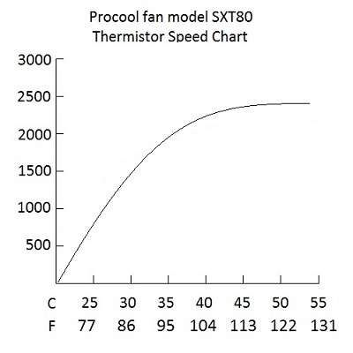

Blade Removal

For cleaning and maintenance, the blade prop can be removed.

Grasp the blade prop and pull straight out of the fan body. Inspect the shaft and lubricate if needed. Any oil will work; light grease works best. Clean blade as needed with a dry cloth. Soap and water can be used if needed, but should be thoroughly rinsed and dried before use. Reinstall the blade; when properly installed the blade will snap into place.