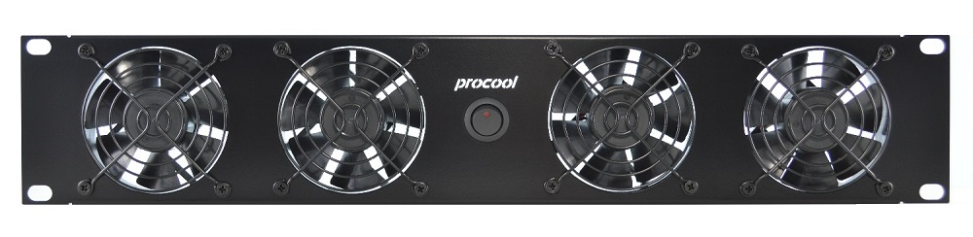ProCooL_LOGO 3.jpgProCooL_LOGO 3.jpgPicture is not the actual product but is for representation only.

\* Model No. **TDC2280** (intake), **TDC2280-E** (exhaust)

|  |  |
| --- | --- |
| Panel Size: | (2U) 19" x 3.5" x 3" |
| Panel Color/Material: | Black/Metal |
| Fans: | 4 |
| Fan Size: | 80mm x 80mm x 38mm |
| Fan Speed: | 4900 RPM |
| Air Flow: | 274 CFM |
| Noise: | 54.5 dBA |
| Bearings: | Ball bearings |
| Static Pressure | 0.591 in H2O |
| Power Supply: | 12VDC/5A (not included) |
| Power Supply Connector | 2.1mm barrel |
| Current draw: | 2.32 A |
| Power consumption: | 27.8 W |
| Grills/Guards: | Black Wire |

\*\*\* See following data sheet for Delta fan model FFB0812SHE specifications.

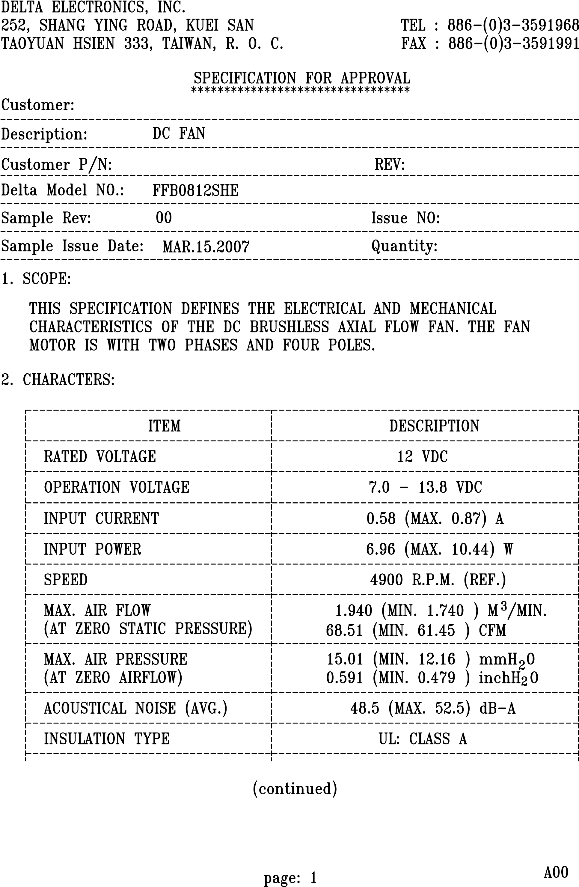

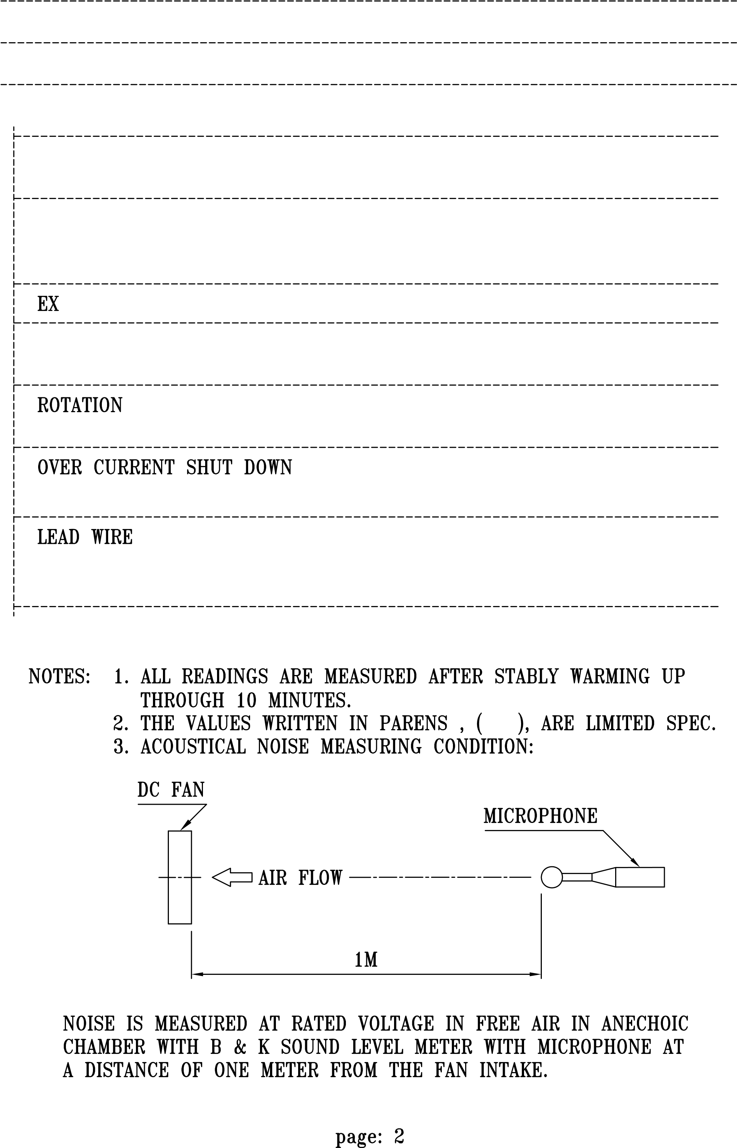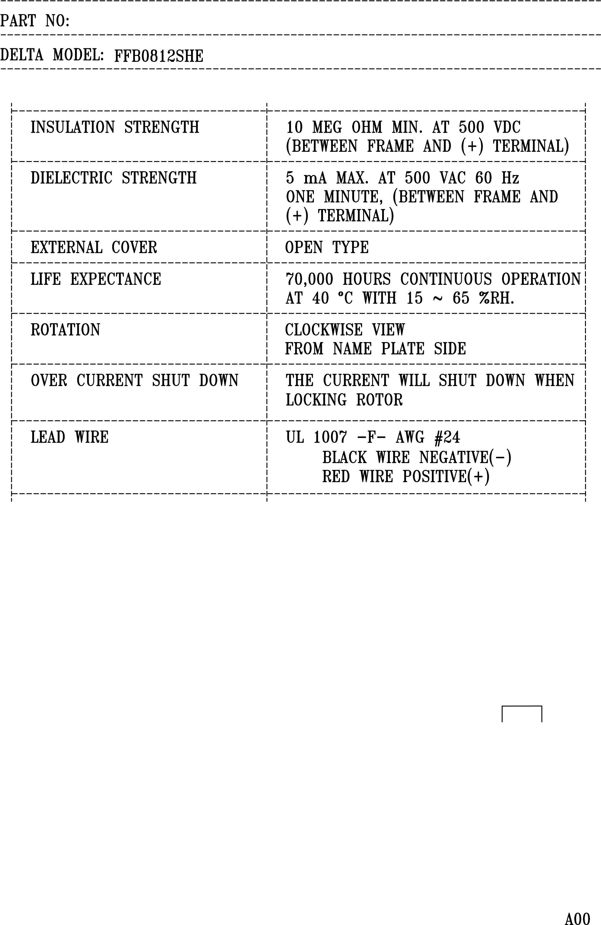

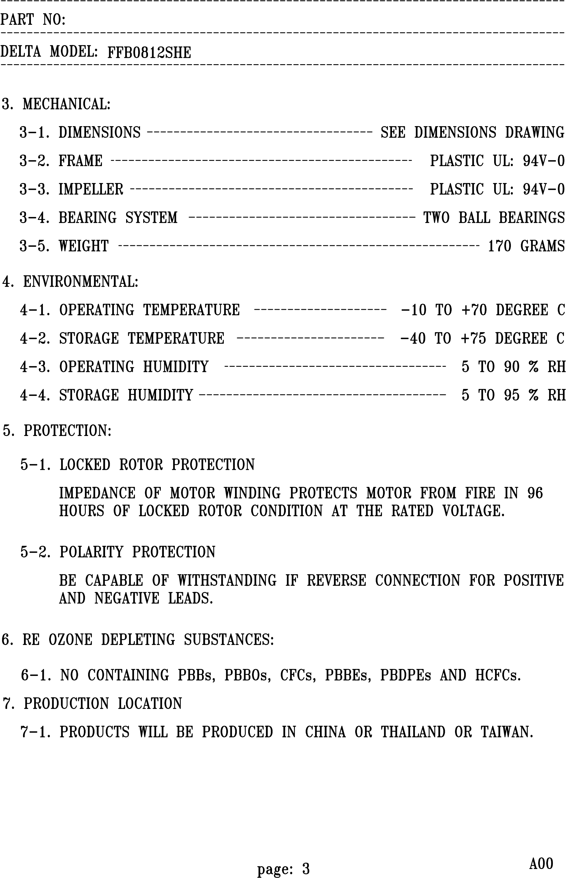

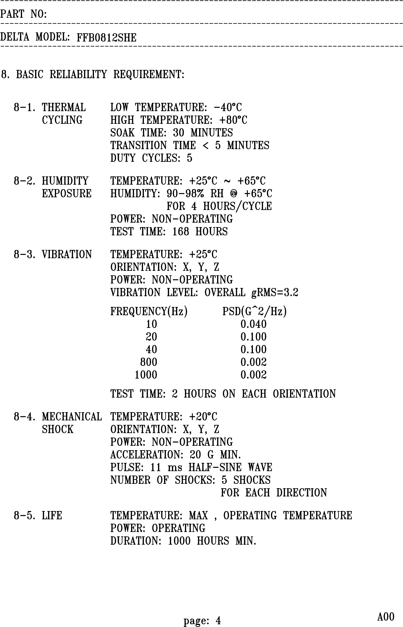

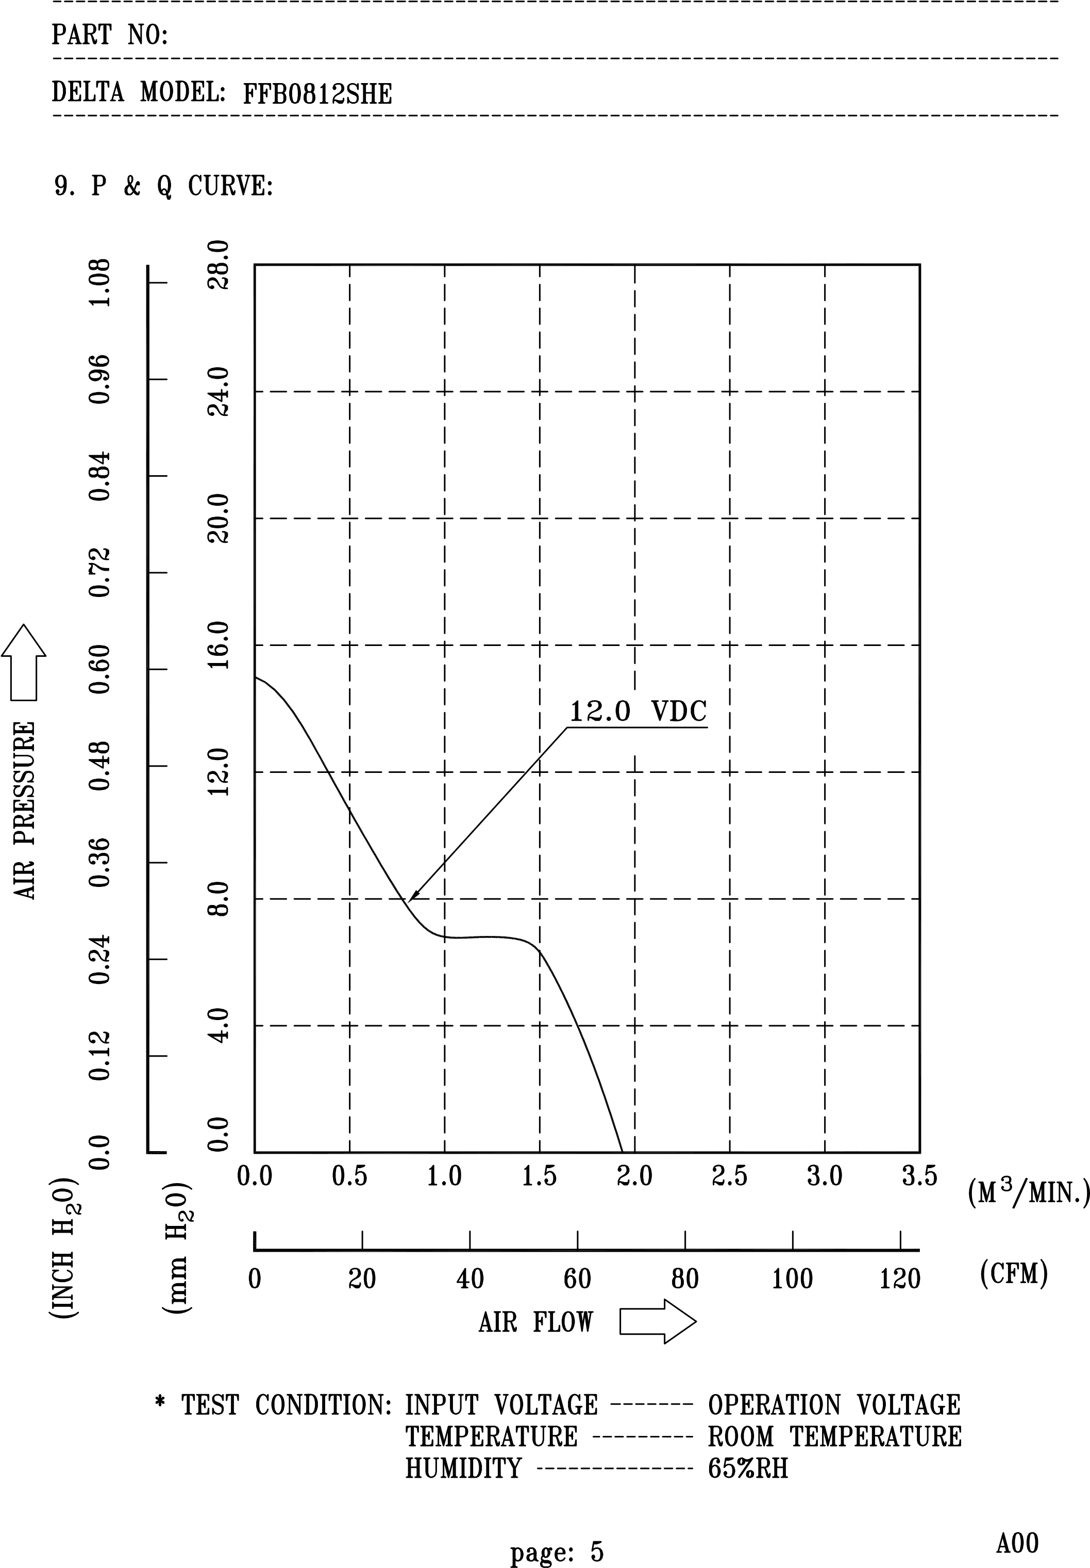

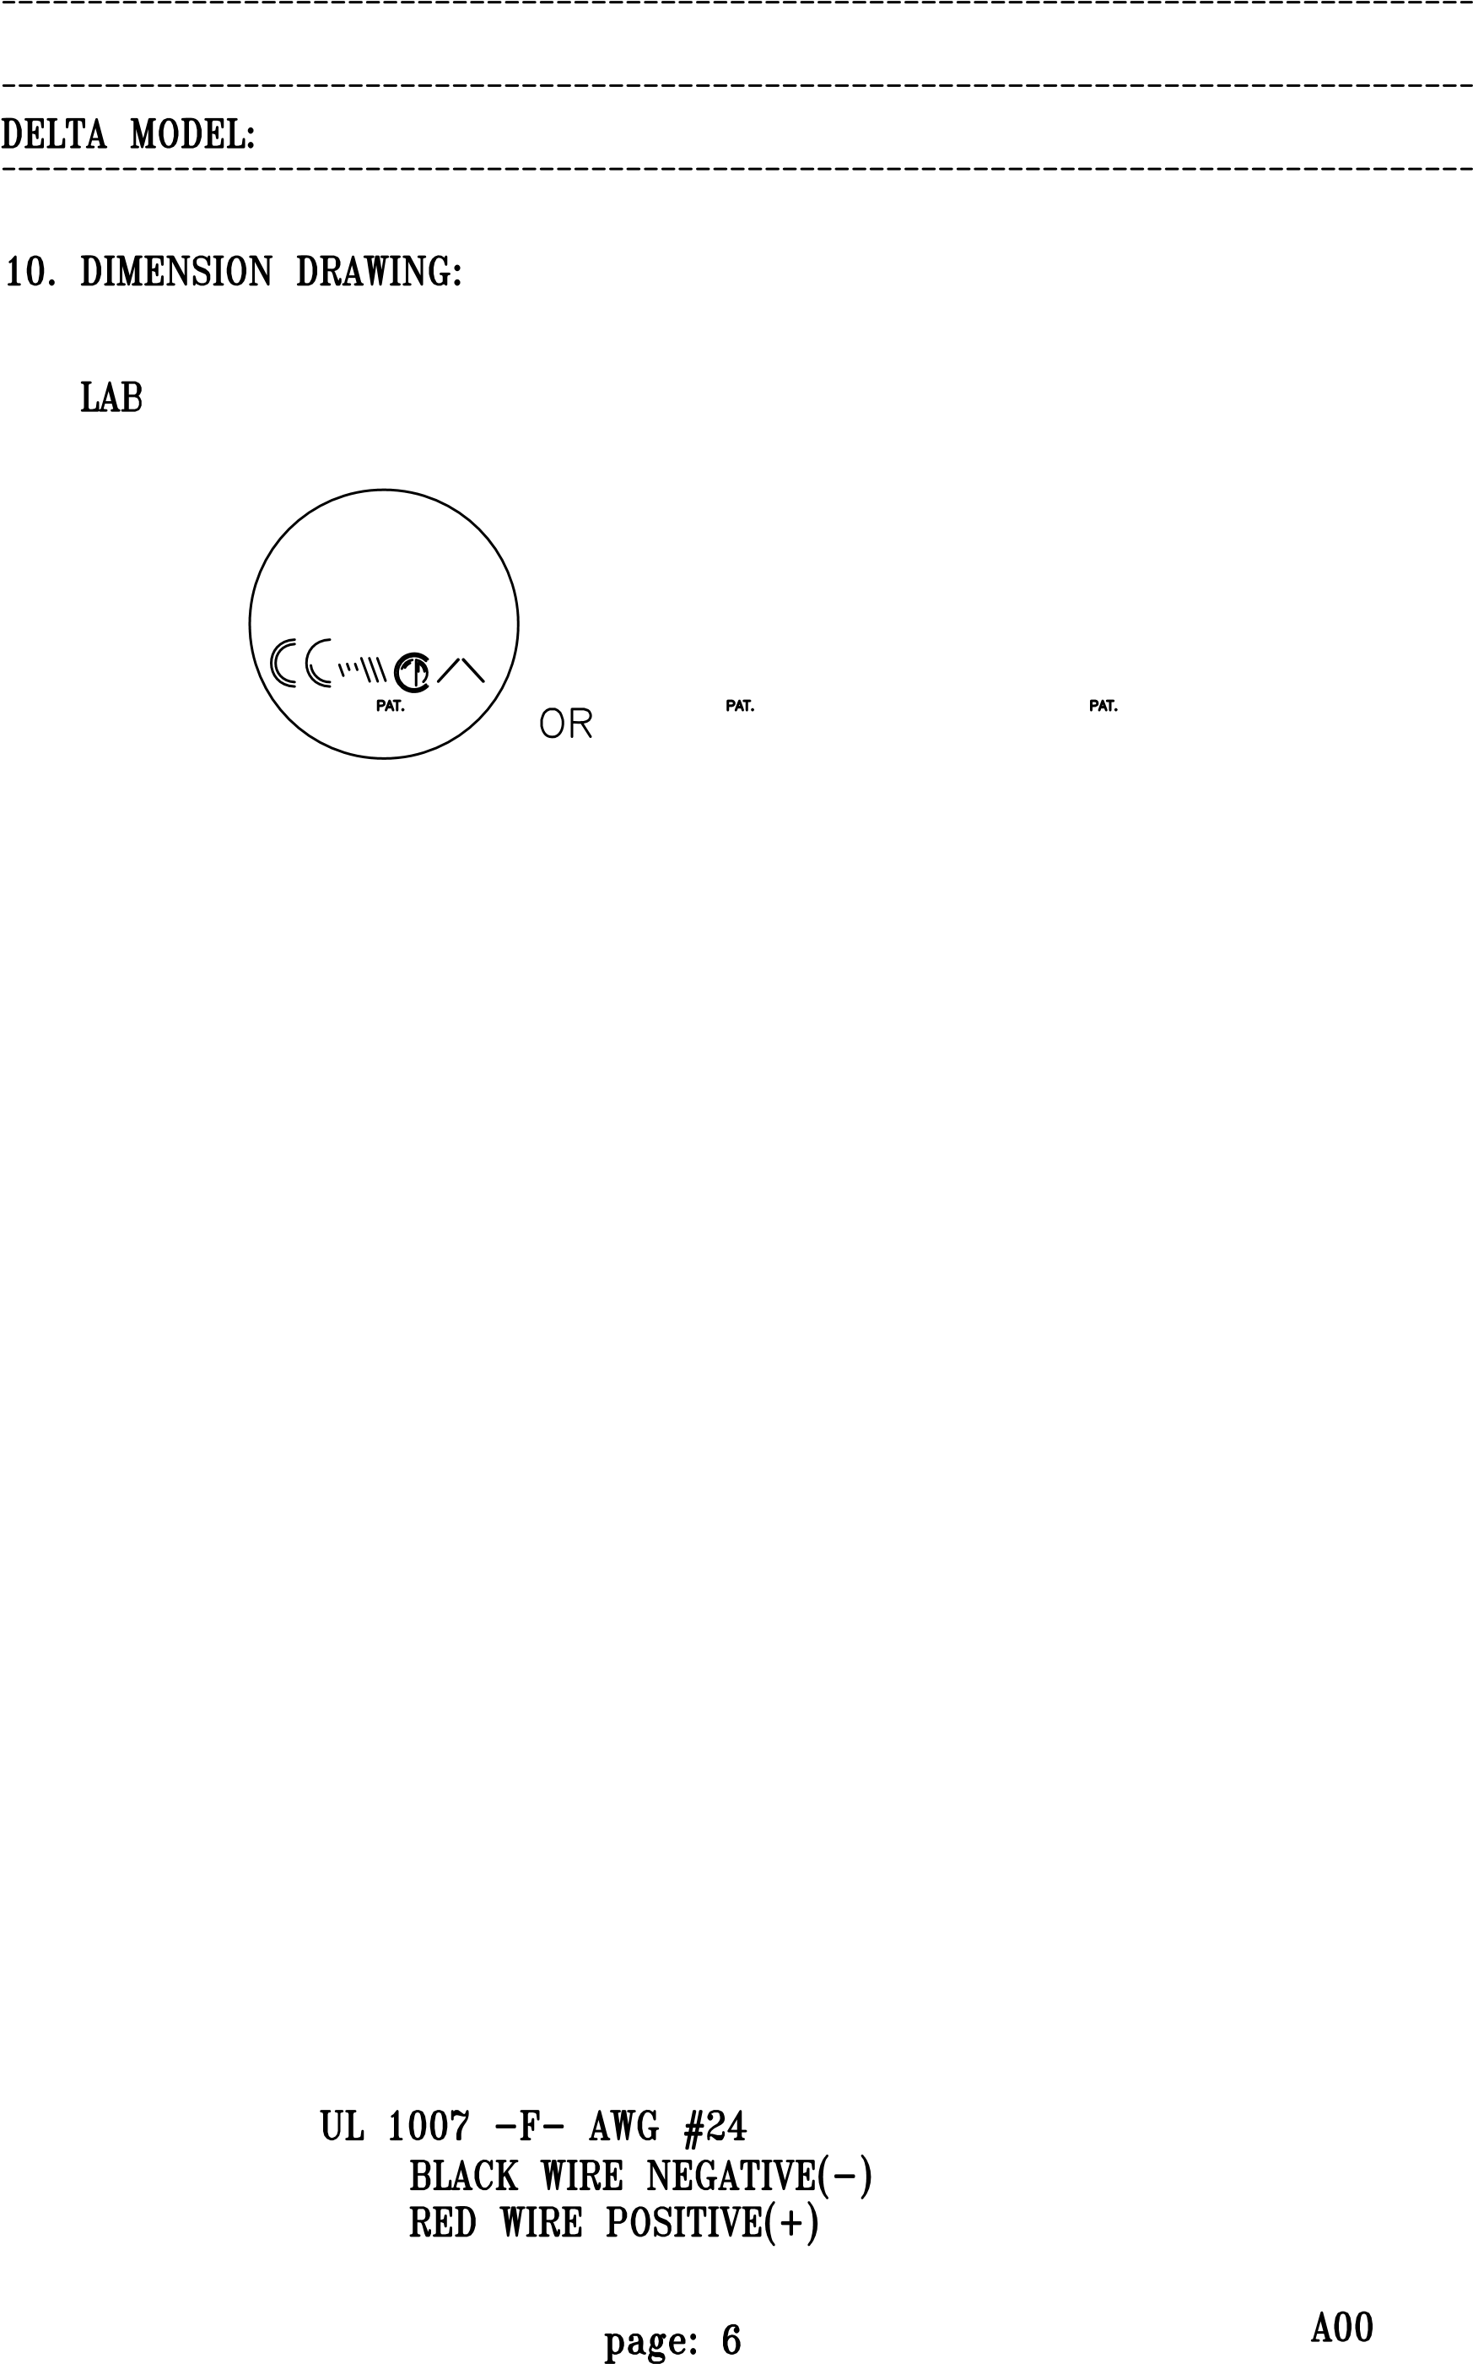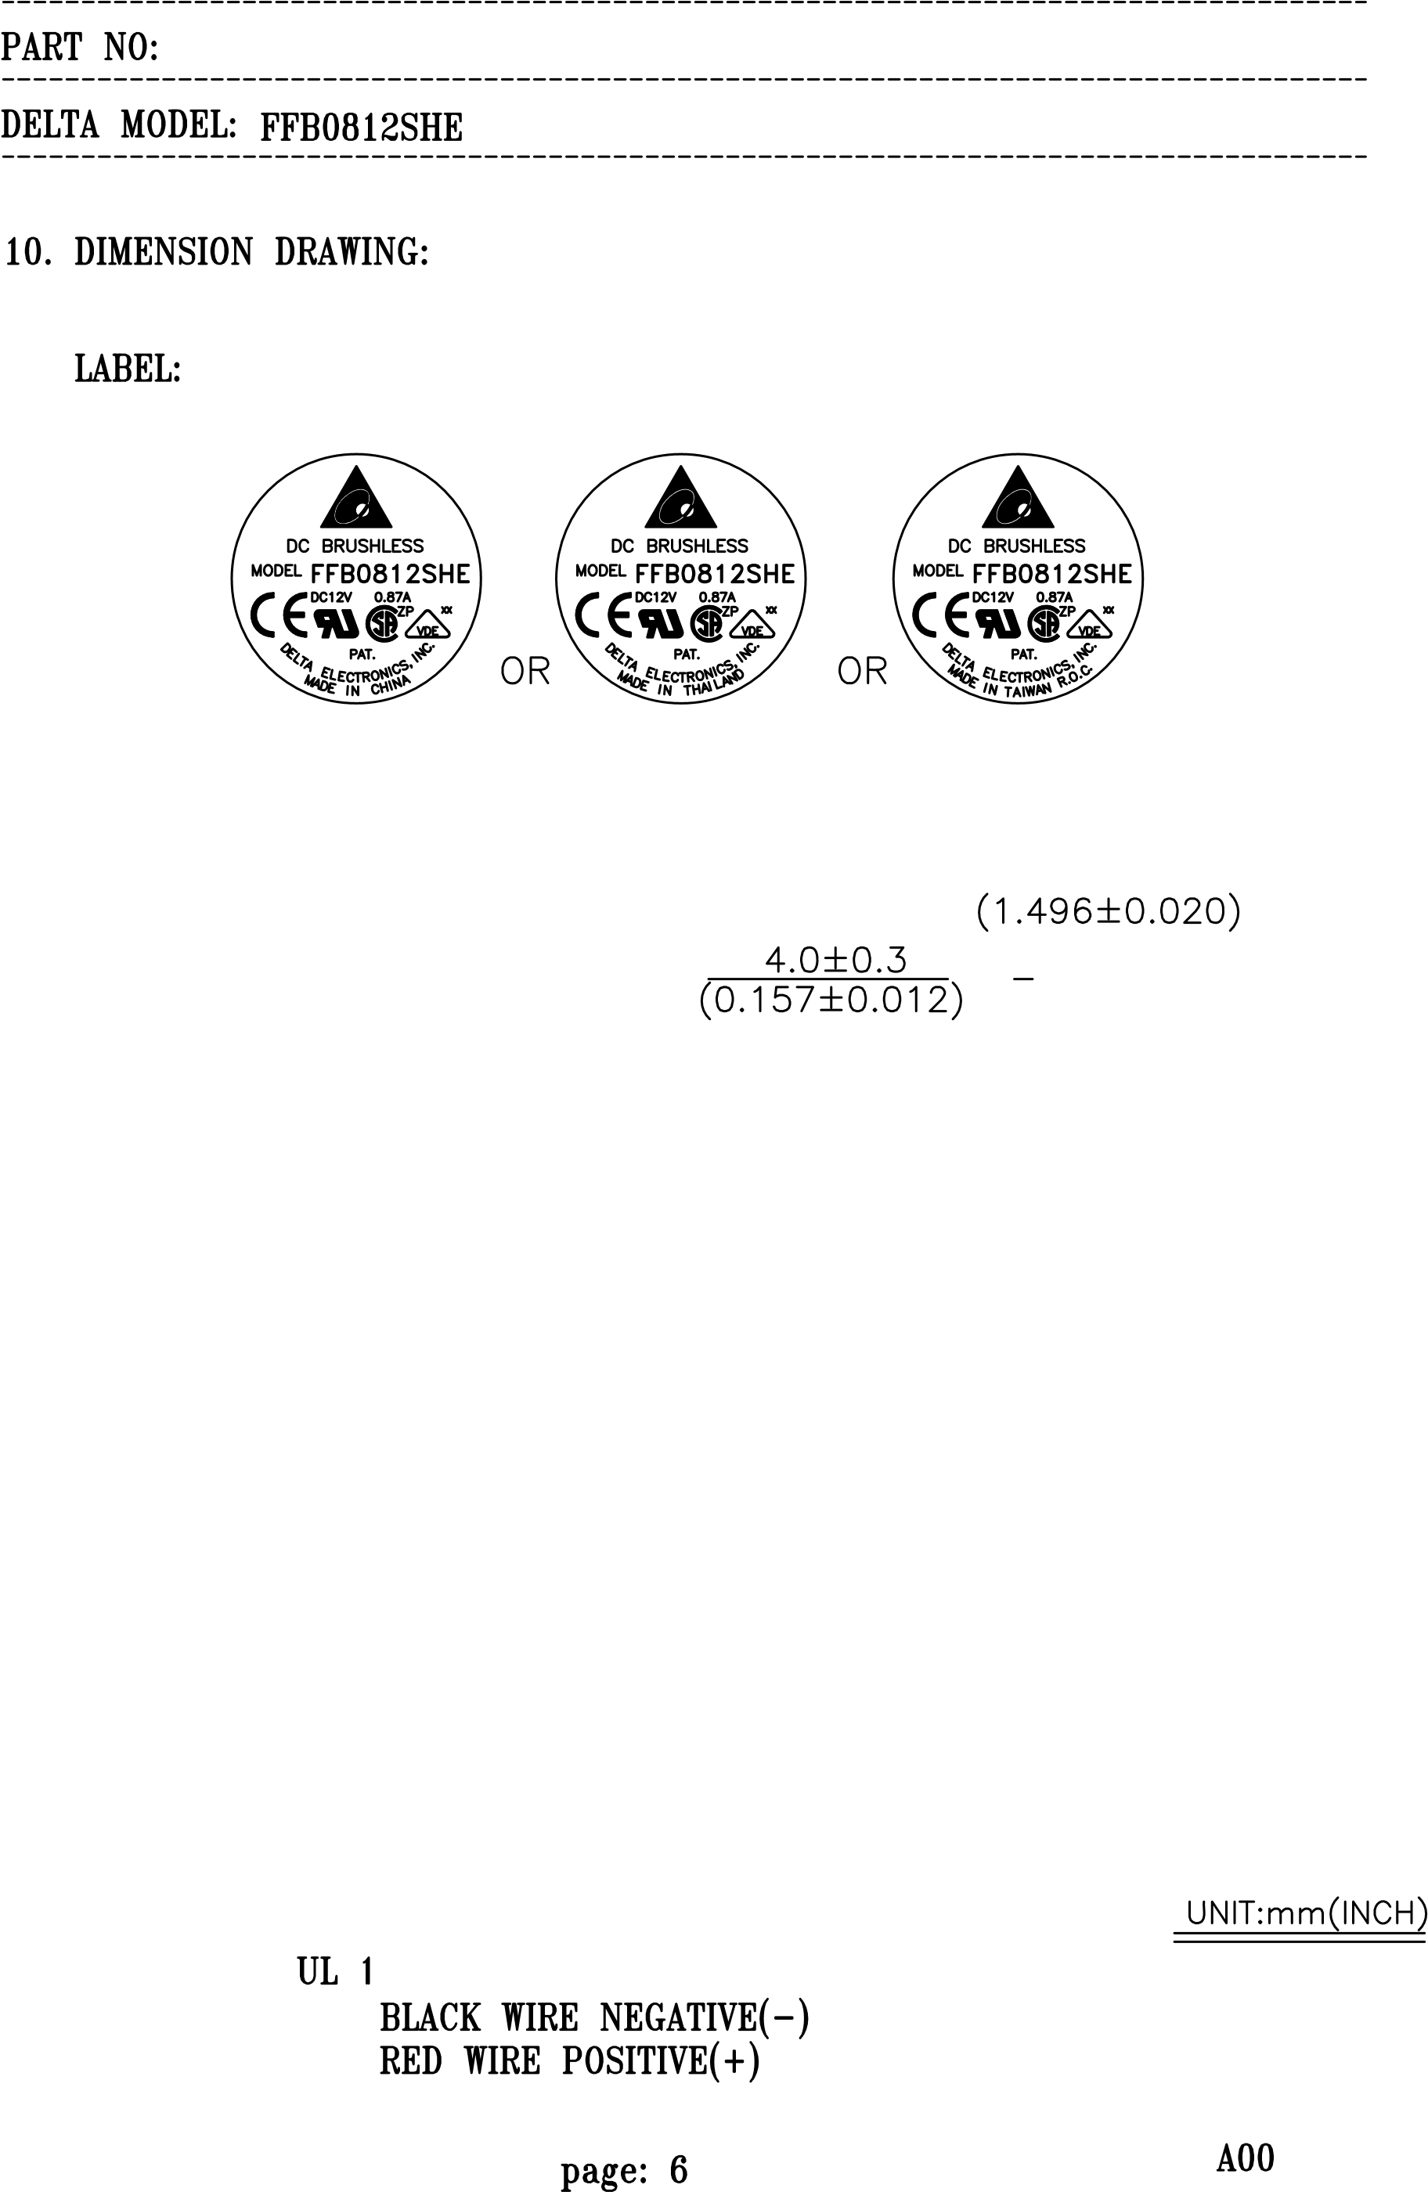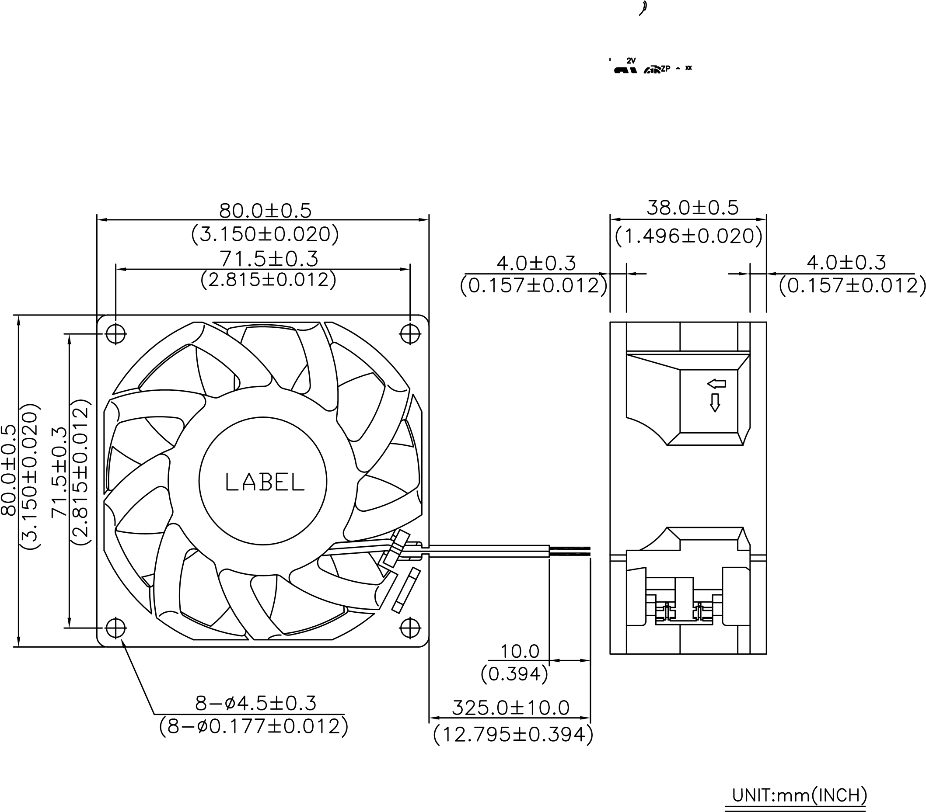

Descriptions:

1. Delta will not guarantee the performance of the products if the application condition falls outside the parameters set forth in the specification.

1. A written request should be submitted to Delta prior to approval if deviation from this specification is required.

1. Please exercise caution when handling fans. Damage may be caused when pressure is applied to the impeller, if the fans are handled by the lead wires, or if the fans are hard-dropped to the production floor.

1. Except as pertains to some special designs, there is no guarantee that the products will be free from any such safety problems or failures as caused by the introduction of powder, droplets of water or encroachment of insect into the hub.

1. The above-mentioned conditions are representative of some unique examples and viewed as the first point of reference prior to all other information.

1. It is very important to establish the correct polarity before connecting the fan to the power source. Positive (+) and Negative (-). Damage may be caused to the fans if connection is with reverse polarity, as there is no foolproof method to protect against such error.

1. Delta fans are not suitable where any corrosive fluids are introduced to their environment.



1. Please ensure all fans are stored according to the storage temperature limits specified. Do not store fans in a high humidity environment. We highly recommend performance testing is conducted before shipping, if the fans have been stored over 6 months.

1. Not all fans are provided with the Lock Rotor Protection feature. If you impair the rotation of the impeller for the fans that do not have this function, the performance of those fans will lead to failure.

1. Please be cautious when mounting the fan. Incorrect mounting of fans may cause excess resonance, vibration and subsequent noise.

1. It is important to consider safety when testing the fans. A suitable fan guard should be fitted to the fan to guard against any potential for personal injury.

1. Except where specifically stated, all tests are carried out at relative (ambient) temperature and humidity conditions of 25oC, 65%. The test value is only for fan performance itself.

1. Be certain to connect an “over 4.7µF” capacitor to the fan externally when the application calls for using multiple fans in parallel, to avoid any unstable power.