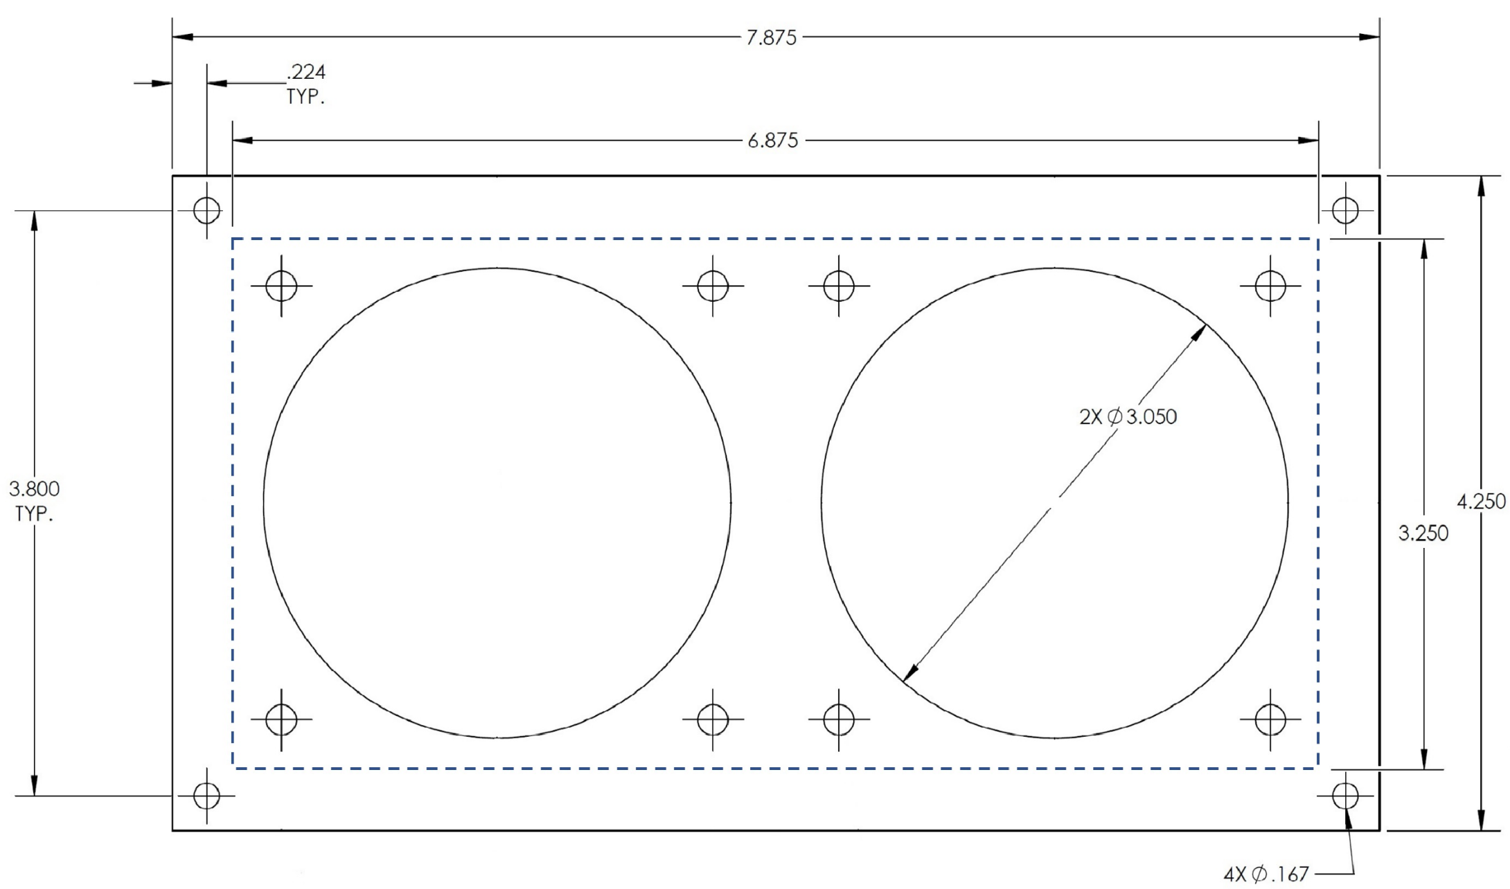

Cut out template for AV-M280 dual 80mm fan mounting plate.

Cut on the dotted line.