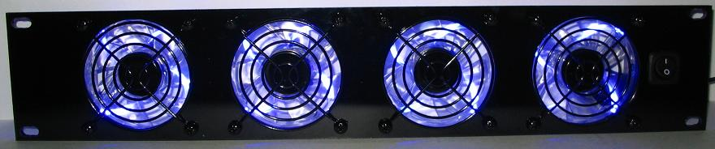

ProCooL_LOGO 3.jpgProCooL_LOGO 3.jpg

\* Model No.

**SL480B – Blue fans**

**SL480G – Green fans**

**SL480P – Purple fans**

**SL480R – Red fans**

|  |  |
| --- | --- |
| Panel SIze: | (2U) 19" x 3.5" x 1.5" |
| Panel Color/Material: | Black/Lexan |
| Fans: | 4 |
| Fan Color | Blue, Green, Purple, Red |
| Fan Size: | 80mm x 80mm x 25mm |
| Fan Speed: | 1800 RPM |
| Air Flow: | 86.8 CFM |
| Noise: | 26 dBA |
| Bearings: | Hydraulic |
| Thermal Probe length | n/a |
| Power Supply: | 100-240 VAC/12VDC/5VDC |
| Power Supply Cable length | AC-60" DC-36" |
| Current draw: | .64A |
| Power consumption: | 7.68w |
| Grills/Guards: | Black Wire |