**PROCOOL SP640 SERIES TEMPERATURE CONTROLLED COOLING SYSTEMS**

*Intake Models:* *SP640X, SP640TV*

*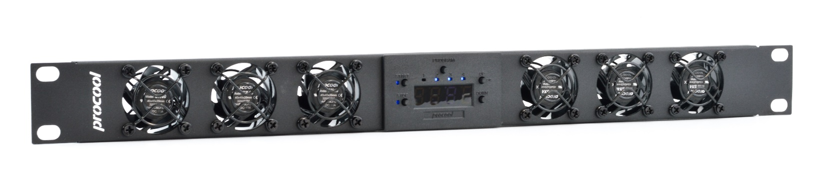Exhaust Models: SP640X-E, SP640TV-E*

|  |  |  |
| --- | --- | --- |
| **Model No.** | **SP640X, SP640X-E** | **SP640TV, SP640TV-E** |
|  | Quiet Operation | High Airflow |
|  |  |  |
| Panel Size: | 1U (19"w x 1.75"h x 2”d) | 1U (19"w x 1.75"h x 2”d) |
| Panel color/material: | Black/metal | Black/metal |
| Fan Size: | 40mm x 40mm x 20mm | 40mm x 40mm x 2mm |
| Number of Fans: | 6 | 6 |
| Fan Speed (per fan): | 3200 RPM | 5000 RPM |
| Air Flow Direction | INTAKE (*E = EXHAUST) | INTAKE (*E = EXHAUST) |
| Air Flow (combined): | 36 CFM | 48 CFM |
| Static Pressure (per fan): | - | 2.66mm H²O |
| Noise (combined): | 21.77 dBA | 30.78 dBA |
| Thermistor Probe length | n/a | n/a |
| Grills/Guards: | Black Wire | Black Wire |
| Bearings: | Fluid Dynamic | Dual Ball Bearings |
| Power Supply: | 100-240 VAC - 12 VDC | 100-240 VAC - 12 VDC |
| Power Supply Plug: | NEMA 1-15P – 2.1mm | NEMA 1-15P – 2.1mm |
| Power Supply Cable: | 36" | 36" |
| Current draw: | 0.18A | 0.42A |
| Power consumption: | 2.16w | 5.04w |
| Weight | 2 lbs. | 2 lbs. |
| Operating Temperature | 14 ~ 158°F (-10 ~ 70°C) | 14 ~ 158°F (-10 ~ 70°C) |
| Storage Temperature: | -40 ~ 158°F (-40 ~ 70°C) | -40 ~ 158°F (-40 ~ 70°C) |
| Fan Model | SX40 | TV40 |
|  |  |  |

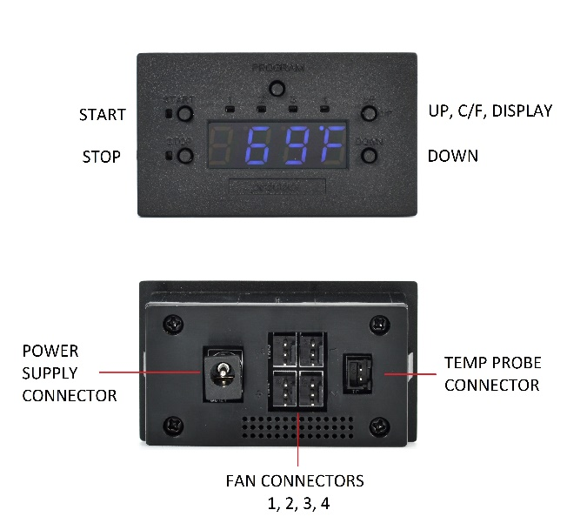

**Features:**  
* Control 4 fans individually with 4 temp zones  
* Large Temperature display (Switchable- on or off)  
* Switch between Fahrenheit and Celsius easily.  
* Switches from thermal control to always on mode  
* Programmable from 32-212°F (0-100 Celsius)  
* 32” thermal probe (48” Extensions are available separately)

Temperature probe

**Instructions:**

**THERMAL PROBE:**Position the probe where you want it to detect the temperature. It can be left as is on the panel for an ambient temp. Or it can be placed at the top of a cabinet or above a hot component. Try to avoid placing the probe where the fans will blow directly on it. For best results, locate the probe where it will detect the most heat.

**PROGRAM:**Press the PROGRAM button to set the on and off temperatures for each of the 4 zones. Press the PROGRAM button to begin. All LED’s will turn on indicating programming for Global Mode. All Zones will operate with the same temperature. Press PROGRAM again to toggle between Zones 1 through 4. The LED for the selected zone will turn on. To exit program mode press PROGRAM until all LED’s turn off. Settings will be automatically saved.

**START / STOP**:  
While in the selected PROGRAM mode, press the START button to set the temperature where the fans should turn on. Use the UP and DOWN buttons to change the temperature. Then press the STOP button to set the temperature where the fans should turn off.

Hold START and STOP together for 3 seconds to switch to Always On mode which bypasses temperature control. The screen will display bp for bypass mode. The fans will continue to run until switched back to temperature mode or powered off.

**UP - C/F - Display**:  
Press the UP button to toggle between Celsius “C” or Fahrenheit “F” (when NOT in Programming mode)  
Press and hold the UP button for 3 seconds to enter DARK mode. The indicator lights and display will shut off. The controller will still function as normal. Repeat to turn the display back on.  
  
**DOWN**:  
Used only for setting the temperature in programming mode.

**HEATING FUNCTION:**Set the START temperature lower than the STOP temperature. The controller will run until the stop temperature is reached and the environment is heated to the set temperature.