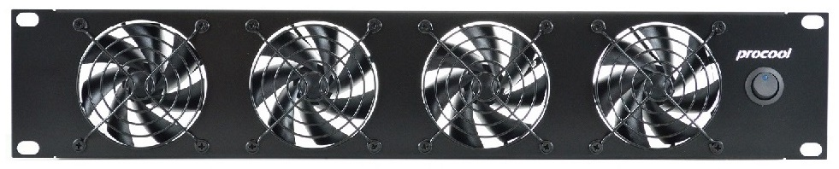ProCooL_LOGO 3.jpgProCooL_LOGO 3.jpg

\* Model No. **SXT480**

|  |  |
| --- | --- |
| **Specifications** | |
| Panel Size: | 19"w x 3.5"h x 1.75” d |
| Panel color/material: | black/metal |
| Fan Size: | 80mm x 80mm x 25mm |
| Number of Fans: | 4 |
| Fan Speed (per fan): | 1200-2400 RPM |
| Air Flow Direction | Intake |
| Air Flow (combined): | 64-128 CFM |
| Noise (combined): | 12-20 dBA |
| Grills/Guards: | Black Wire |
| Bearings: | Fluid Dynamic |
| Power Supply: | 100-240 VAC - 12 VDC |
| Power Supply Cable length | 36" |
| Current draw: | 0.68A |
| Power consumption: | 8.16w |
| Weight | 2 lbs. |
| Operating Temperature | -10°/+70° C |
| Storage Temperature | -40°/+80° C |

**Description:**

PROCOOL SXT480 (2U) Rack Mount Fan/ Black Metal panel/ Black grills/ 4 Silent 80mm Thermistor Fans/ 12-20 dBA @ 56-128 CFM/ Airflow = OUT

Maintenance:

Fan blades should be cleaned when dirt or dust is noticeable. Canned air works best for quick cleaning.

For deeper cleaning you can remove the blade prop. Remove the grill from the front of the panel. Pull firmly outward on the blade prop. Once removed the blade prop can be cleaned and the shaft can be lubricated.

Use any light grease or a heavy oil to re-lubricate the shaft. Do not put lubricant into the fan motor located in the fan frame.

Insert the blade prop back into the fan. Press firmly until you hear it snap into place.

Troubleshooting:

If the fans do not spin or spin abnormally, try pressing fan blades into housing as they may be dislodged.

If the fans begin to make noise, make sure the blades are clean and try lubricating the shaft.

When the fans are new and if the temp is below 70°F the thermistor probe may need to be warmed by hand slightly to get the fan to spin.  
  
If you need assistance call customer service at:  
630-552-8957