Model: T80

***External Dimensions: Performance Graph:***

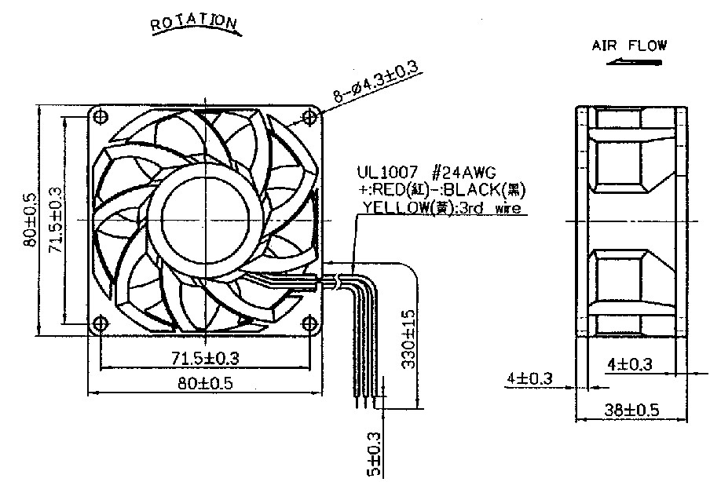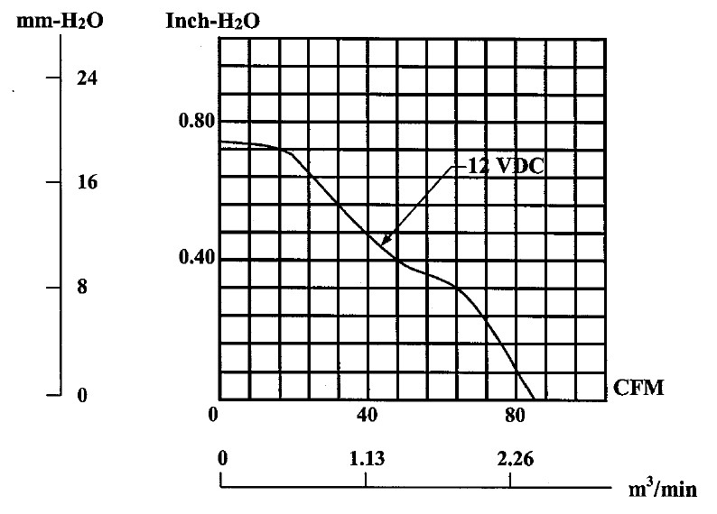

***SPECIFICATIONS:***

|  |  |
| --- | --- |
| Model No.  Dimension  Weight  Rated Voltage Rated Power  Rated Current  Fan Speed  Air Flow  Noise  Bearing System | T80  80X80X38 mm  175 g  12V  9.1 W  0.76 Amp  5700 RPM  84.1 CFM  55.2 dB(A)  Double Ball Bearing |