*procool*  AV & IT Cooling Solutions Model: T80

|  |
| --- |
| Specifications |
| |  |  | | --- | --- | | Fan Size: | 80 x 80 x 38mm | | Fan Speed: | 5700 RPM | | Air Flow: | 84.1 CFM | | Static Pressure: | 0.750 in H2O | | Noise: | 55.2 dBA | | Bearings: | Dual Ball Bearing | | Fan Thermistor wire length: | n/a | | Power wire length: | 12" | | Power Connector: | 3 pin molex | | Rated Voltage: | 12 VDC | | Operating Voltage Range: | 12 VDC | | Current draw: | 0.76A | | Power consumption: | 9.1w | | Operating Temperature: | 14 / 158 ℉ (-10 /+70 ℃) | | Storage Temperature: | -40 / 158 ℉ (-40 /+80 ℃) | | MTBF Hours | Not Evaluated | |

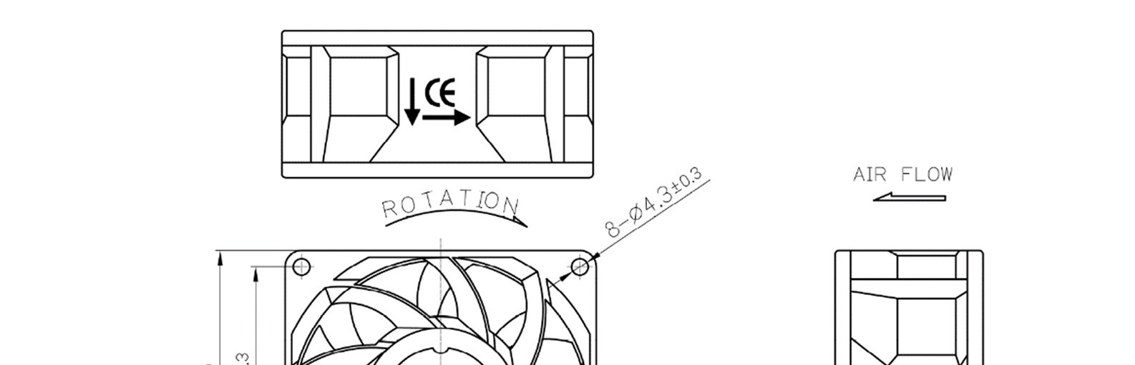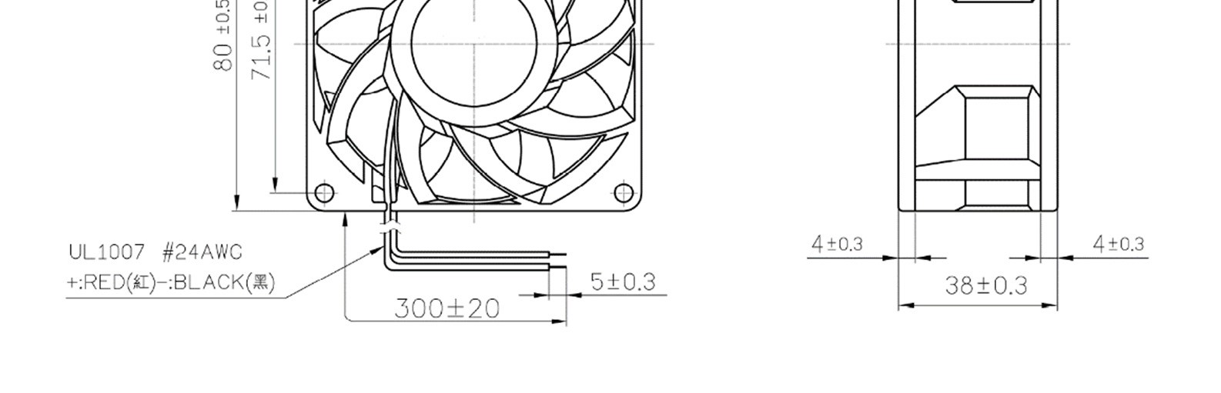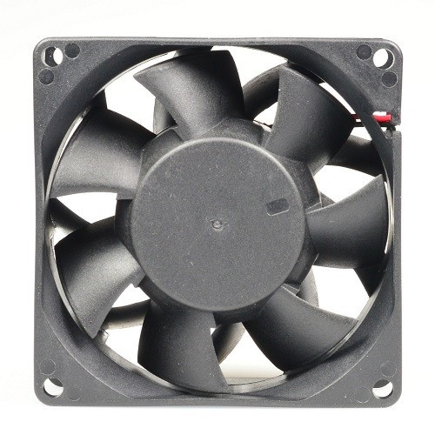

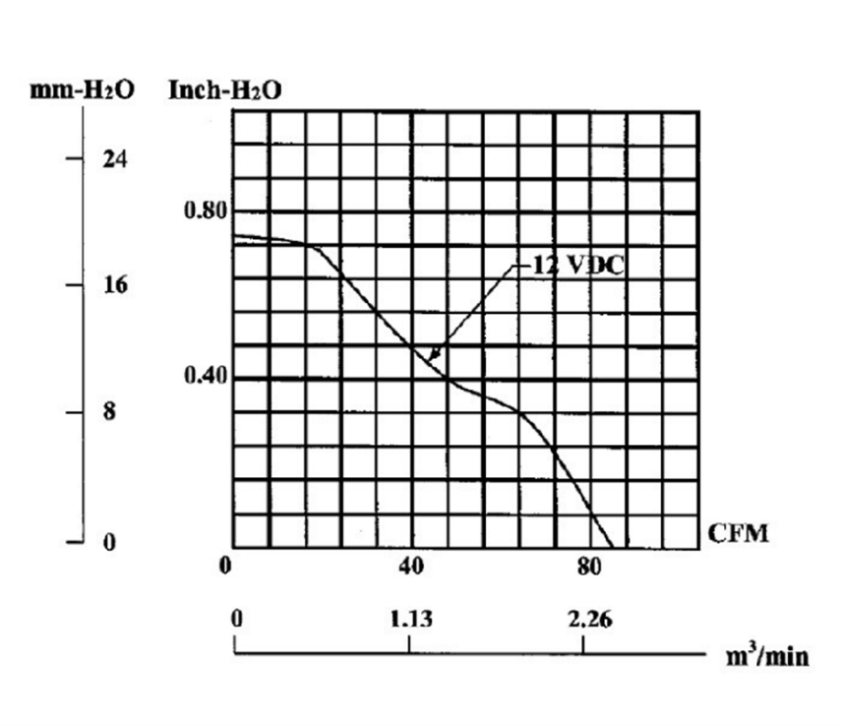 Static Pressure

Maintenance:

Cleaning the fan is the best preventative maintenance. Cleaning frequency would depend on the environment. It is recommended that the blade be cleaned to prevent any buildup of dust. Canned air works well.

Warranty:

3 Years from the date of purchase.