**PROCOOL T80 FAN SERIES RACK MOUNT COOLING SYSTEMS**

*Intake Models: T280, T380, T480 and T2280*

*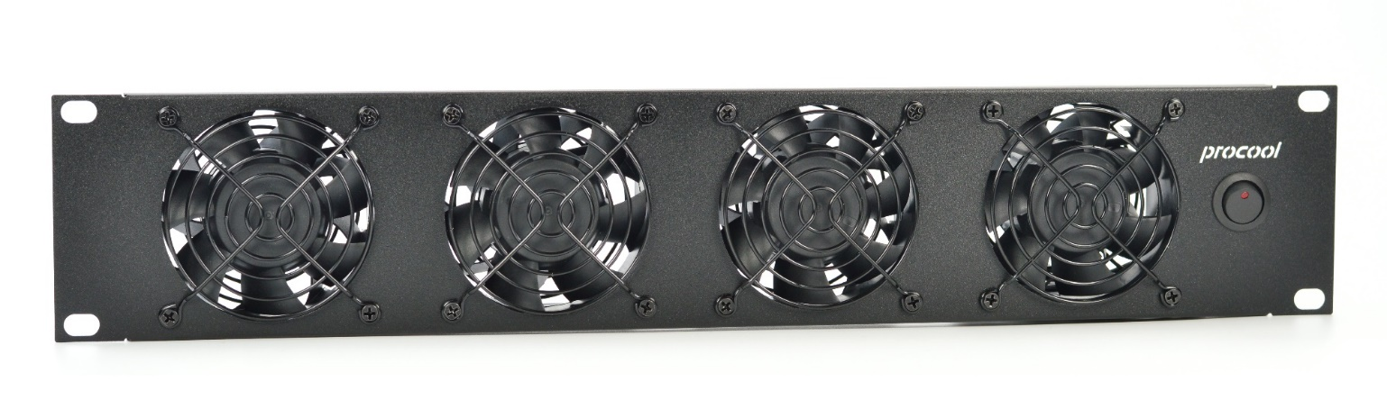Exhaust Models: T280E, T380E, T480E and T2280E*

|  |  |  |  |  |
| --- | --- | --- | --- | --- |
| **Model No.** | **T280, T280E,** | **T380, T380E** | **T480, T480E** | **T2280, T2280E** |
| Panel Size: | 2U (19"w x 3.5"h x 1.75”d) | 2U (19"w x 3.5"h x 1.75”d) | 2U (19"w x 3.5"h x 1.75”d) | 2U (19"w x 3.5"h x 1.75”d) |
| Panel color/material: | Black/metal | Black/metal | Black/metal | Black/metal |
| Fan Size: | 80mm x 80mm x 38mm | 80mm x 80mm x 38mm | 80mm x 80mm x 38mm | 80mm x 80mm x 38mm |
| Number of Fans: | 2 | 3 | 4 | 4 |
| Fan Speed (per fan): | 5700 RPM | 5700 RPM | 5700 RPM | 5700 RPM |
| Air Flow Direction | INTAKE (*E = EXHAUST) | INTAKE (*E = EXHAUST) | INTAKE (*E = EXHAUST) | INTAKE (*E = EXHAUST) |
| Air Flow (combined): | 168 CFM | 252 CFM | 336 CFM | 336 CFM |
| Static Pressure (per fan): | 0.740 in H²O | 0.740 in H²O | 0.740 in H²O | 0.740 in H²O |
| Noise (combined): | 58 dBA | 59 dBA | 61 dBA | 61 dBA |
| Thermistor Probe length | n/a | n/a | n/a | n/a |
| Grills/Guards: | Black Wire | Black Wire | Black Wire | Black Wire |
| Bearings: | Precision Ball Bearings | Precision Ball Bearings | Precision Ball Bearings | Precision Ball Bearings |
| Power Supply: | 100-240 VAC - 12 VDC | 100-240 VAC - 12 VDC | 100-240 VAC - 12 VDC | 100-240 VAC - 12 VDC |
| Power Supply Plug: | NEMA 1-15 – 2.1mm | NEMA 1-15 – 2.1mm | NEMA 1-15 – 2.1mm | NEMA 1-15 – 2.1mm |
| Power Supply Cable: | 36" | 36" | 36" | 36" |
| Current draw: | 1.52A | 2.28A | 3.04A | 3.04A |
| Power consumption: | 18.2w | 27.3w | 36.4w | 36.4w |
| Weight | 2 lbs. | 2 lbs. | 2 lbs. | 2 lbs. |
| Operating Temperature | 14 ~ 158°F (-10 ~ 70°C) | 14 ~ 158°F (-10 ~ 70°C) | 14 ~ 158°F (-10 ~ 70°C) | 14 ~ 158°F (-10 ~ 70°C) |
| Storage Temperature: | -40 ~ 158°F (-40 ~ 70°C) | -40 ~ 158°F (-40 ~ 70°C) | -40 ~ 158°F (-40 ~ 70°C) | -40 ~ 158°F (-40 ~ 70°C) |
|  |  |  |  |  |
|  |  |  |  |  |

* Specifications are subject to change without notice.

**Model T80 Ultra High Airflow Fan**The T80 series of fans provide an ultra high airflow cooling solution. Recommended where extreme cooling is required.  
The T80 fans provide 81 CFM of airflow with 52 dBA of noise.

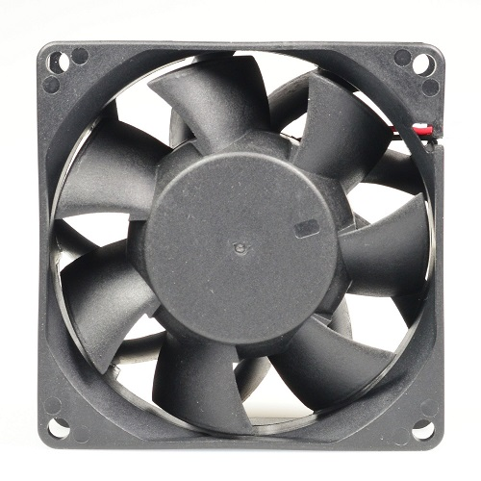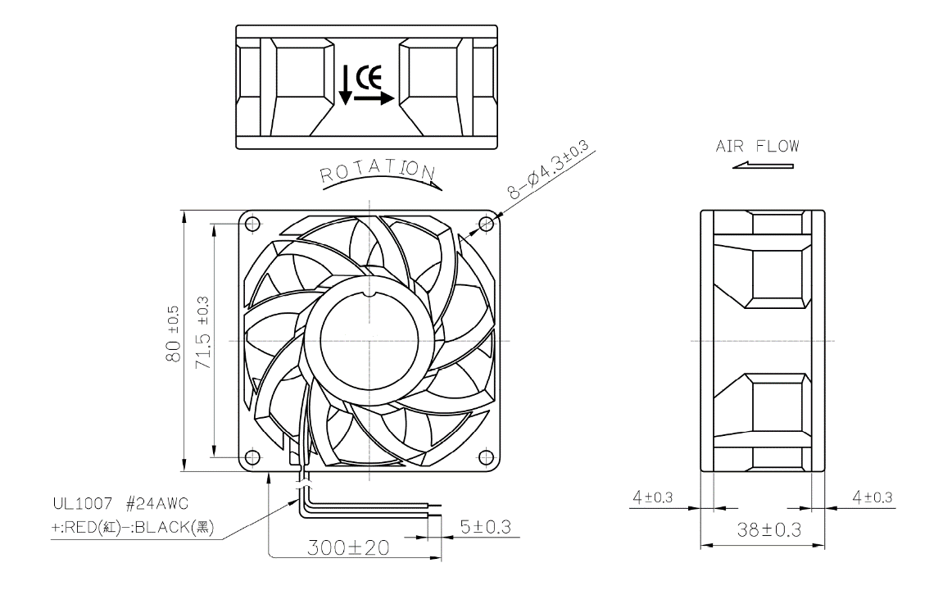

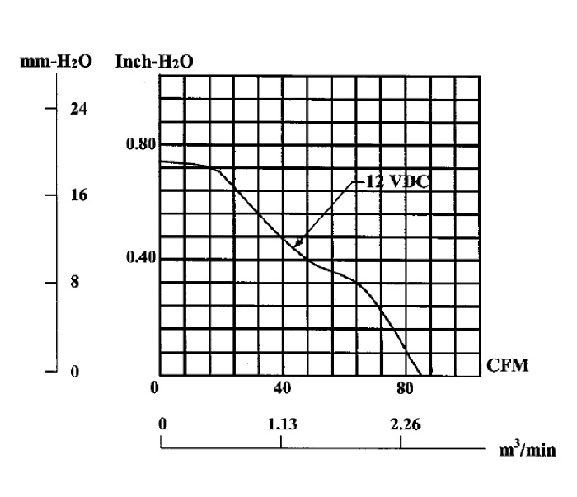 **Static Pressure**

|  |  |
| --- | --- |
| Model T80 Specifications | |
| Fan Size: | 80mm x 80mm x 38mm |
| Speed: | 5700 RPM |
| Air Flow: | 84 CFM |
| Static Pressure: | 0.740 in H²O |
| Noise: | 55 dBA |
| Thermistor Probe length | n/a |
| Grills/Guards: | Black Wire |
| Bearings: | Precision Ball Bearings |
| Voltage Range: | 6 ~ 13.8VDC |
| Rated Voltage: | 12VDC |
| Current draw: | 0.76A |
| Power consumption: | 9.1w |
| Weight: | 0.386 lb (175.09g) |
| Operating Temperature: | 14 ~ 158°F (-10 ~ 70°C) |
| Storage Temperature: | -40 ~ 158°F (-40 ~ 70°C) |

|  |
| --- |
| MTBF Hours |
| Has not been evaluated |

**Maintenance:**

Cleaning the fan is the best preventative maintenance. Cleaning frequency would depend on the environment. It is recommended that the blade be cleaned to prevent any buildup of dust. Canned air works well.

**Warranty:**

3 Years from the date of purchase.