***procool* TV2240 & TV2240E**

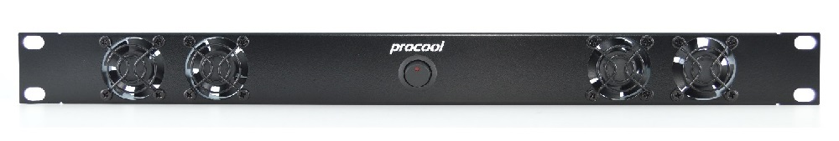

ProCooL_LOGO 3.jpgProCooL_LOGO 3.jpg

**Manufacturer:** PROCOOL LLC   
**Model No.** TV2240 (intake), TV2240-E (exhaust)   
**Description:** High power 1U rack mount cooling system

**Specifications:**

|  |  |
| --- | --- |
| Panel Size | (1U) 19" x 1.75" x 1.5" |
| Panel Color / Material | Black Powder Coat / Metal |
| Fans | 4 |
| Fan Model | Procool TV40 |
| Fan Size | 40mm x 40mm x 20mm |
| Bearings | Dual Ball bearings |
| Fan Speed | 6000 RPM |
| Air Flow (per fan) | 7.17 CFM |
| Air Flow (combined) | 28 CFM |
| Static Pressure (per fan) | 4.10mm H2O |
| Noise (per fan) | 26 dBA |
| Noise (combined) | 32 dBA |
| Power consumption | 2.88 W |
| Current draw | 0.24 A |
| Power Supply | 100-240 VAC - 12VDC/1A |
| Power Supply AC Connector | NEMA 1-15P |
| Power Supply DC Connector | 2.1mm barrel plug |
| Grills/Guards | Black Wire |
| Weight | 1 lb. 8 oz. |

