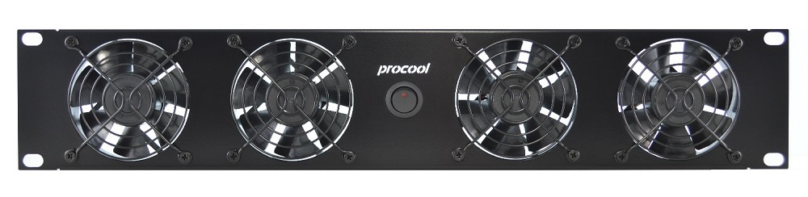***procool* TV2280 & TV2280E**

ProCooL_LOGO 3.jpgProCooL_LOGO 3.jpg

**Manufacturer:** PROCOOL LLC   
**Model No.** TV2280 (intake), TV2280-E (exhaust)   
**Description:** High power rack mount cooling system

**Specifications:**

|  |  |
| --- | --- |
| Panel Size | (2U) 19" x 3.5" x 1.5" |
| Panel Color / Material | Black Powder Coat / Metal |
| Fans | 4 |
| Fan Model | Procool TV80 |
| Fan Size | 80mm x 80mm x 25mm |
| Bearings | Dual Ball bearings |
| Fan Speed | 4200 RPM |
| Air Flow (per fan) | 53 CFM |
| Air Flow (combined) | 212 CFM |
| Static Pressure (per fan) | 0.26 in H2O |
| Noise (per fan) | 39 dBA |
| Noise (combined) | 45 dBA |
| Power consumption | 27.8 W |
| Current draw | 1.92 A |
| Power Supply | 100-240 VAC - 12VDC/2A |
| Power Supply AC Connector | NEMA 1-15P |
| Power Supply DC Connector | 2.1mm barrel plug |
| Grills/Guards | Black Wire |
| Weight | 1 lb. 8 oz. |

