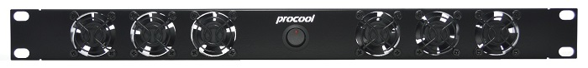ProCooL_LOGO 3.jpgProCooL_LOGO 3.jpg

**Model No.**

TV640 & TV640E

**Description:**

PROCOOL TV640 & TV640E (1U) Rack Mount Fan/ Black Metal Panel/ Black wire grills/ 6x 40mm TV40 TURBO fans/ 33.77 dBA @ 42.6 CFM

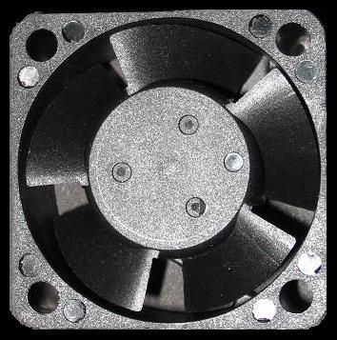

Procool Fan model TV40

|  |  |
| --- | --- |
| **Specifications** | |
| Panel Size: | standard 19"w x 1.75"h x 1.5”d |
| Panel color/material: | Black metal |
| Fan Size: | 40mm x 40mm x 20mm |
| Number of Fans: | 6 |
| Fan Speed (per fan): | 6000 RPM |
| Air Flow Direction | TV640=IN TV640E=EXHAUST |
| Air Flow (combined): | 42.6 CFM |
| Noise (combined): | 33.77 dBA |
| Grills/Guards: | Black Wire |
| Bearings: | Ball |
| Power Supply: | 100-240 VAC - 12 VDC |
| Power Supply Cable length | 48" |
| Current draw: | 0.36A |
| Power consumption: | 4.32w |
| Weight | 1.5 lbs. |
| MTBF Hours | 50,000 |
| Operating Temperature | -10°/+70° C |
| Storage Temperature | -40°/+80° C |

*Specifications are subject to change without notice*

*Specifications are subject to change without notice*