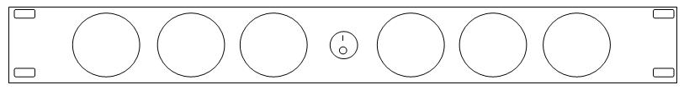ProCooL_LOGO 3.jpgProCooL_LOGO 3.jpg

**Description:**

***“More airflow with less noise”***

PROCOOL TV640E Exhaust (1U) Rack Mount Fan/ Black Lexan Panel/ Black wire grills/ 6x 40mm TURBO fans/ 33.77 dBA @ 42.6 CFM/ Airflow = Exhaust

The Procool TV640E is designed for industrial applications that require high airflow in one 19” rack space.

Procool provides a wide variety of rack mount and cabinet cooling systems.

With 3, 4 and 6 fan systems built on a 1U platform to accommodate any application.

Visit www.rackfans.com for a complete selection of cooling fan systems.

All Procool fans can be customized to the customer’s specific requirements, including custom sized panels and colors.

Further customizing includes the addition of plugs and jacks into the panel for ease and convenience of interconnecting other components.

Call to discuss specific requirements.

\* Model No. **TV640E**

|  |  |
| --- | --- |
| **Specifications** | |
| Panel Size: | standard 19"w x 1.75"h x 1.5”d |
| Panel color/material: | black/lexan |
| Fan Size: | 40mm x 40mm x 20mm |
| Number of Fans: | 6 |
| Fan Speed (per fan): | 6000 RPM |
| Air Flow Direction | Exhaust |
| Air Flow (combined): | 42.6 CFM |
| Noise (combined): | 33.77 dBA |
| Grills/Guards: | Black Wire |
| Bearings: | Ball |
| Power Supply: | 100-240 VAC - 12 VDC |
| Power Supply Cable length | 48" |
| Current draw: | 0.36A |
| Power consumption: | 4.32w |
| Weight | 1.5 lbs. |
| Operating Temperature | -10°/+70° C |
| Storage Temperature | -40°/+80° C |

*Specifications are subject to change without notice*