**PROCOOL TV80 FAN SERIES RACK MOUNT COOLING SYSTEMS**

*Intake Models: TV280, TV380, TV480 and TV2280*

*Exhaust Models: TV280E, TV380E, TV480E and T2280E*

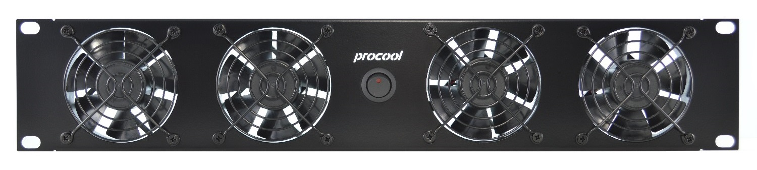

|  |  |  |  |  |
| --- | --- | --- | --- | --- |
| **Model No.** | **TV280, TV280E,** | **TV380, TV380E** | **TV480, TV480E** | **TV2280, TV2280E** |
| Panel Size: | 2U (19"w x 3.5"h x 1.5”d) | 2U (19"w x 3.5"h x 1.5”d) | 2U (19"w x 3.5"h x 1.5”d) | 2U (19"w x 3.5"h x 1.5”d) |
| Panel color/material: | Black/metal | Black/metal | Black/metal | Black/metal |
| Fan Size: | 80mm x 80mm x 38mm | 80mm x 80mm x 38mm | 80mm x 80mm x 38mm | 80mm x 80mm x 38mm |
| Number of Fans: | 2 | 3 | 4 | 4 |
| Fan Speed (per fan): | 4200 RPM | 4200 RPM | 4200 RPM | 4200 RPM |
| Air Flow Direction | INTAKE (*E = EXHAUST) | INTAKE (*E = EXHAUST) | INTAKE (*E = EXHAUST) | INTAKE (*E = EXHAUST) |
| Air Flow (combined): | 106 CFM | 159 CFM | 212 CFM | 212 CFM |
| Static Pressure (per fan): | 0.740 in H²O | 0.740 in H²O | 0.740 in H²O | 0.740 in H²O |
| Noise (combined): | 42 dBA | 44 dBA | 45 dBA | 45 dBA |
| Thermistor Probe length | n/a | n/a | n/a | n/a |
| Grills/Guards: | Black Wire | Black Wire | Black Wire | Black Wire |
| Bearings: | Precision Ball Bearings | Precision Ball Bearings | Precision Ball Bearings | Precision Ball Bearings |
| Power Supply: | 100-240 VAC - 12 VDC | 100-240 VAC - 12 VDC | 100-240 VAC - 12 VDC | 100-240 VAC - 12 VDC |
| Power Supply Plug: | NEMA 1-15 – 2.1mm | NEMA 1-15 – 2.1mm | NEMA 1-15 – 2.1mm | NEMA 1-15 – 2.1mm |
| Power Supply Cable: | 36" | 36" | 36" | 36" |
| Current draw: | 0.96A | 1.44A | 1.92A | 1.92A |
| Power consumption: | 11.52w | 17.28w | 23.04w | 23.04w |
| Weight | 1 lb. | 1 lb. | 1.25 lbs. | 1.5 lbs. |
| Operating Temperature | 14 ~ 158°F (-10 ~ 70°C) | 14 ~ 158°F (-10 ~ 70°C) | 14 ~ 158°F (-10 ~ 70°C) | 14 ~ 158°F (-10 ~ 70°C) |
| Storage Temperature: | -40 ~ 158°F (-40 ~ 70°C) | -40 ~ 158°F (-40 ~ 70°C) | -40 ~ 158°F (-40 ~ 70°C) | -40 ~ 158°F (-40 ~ 70°C) |
|  |  |  |  |  |
|  |  |  |  |  |

* Specifications are subject to change without notice.

**Model TV80 Ultra High Airflow Fan**The TV80 series of fans provide a high airflow cooling solution. Recommended where extreme cooling is required.  
The TV80 fans provide 53 CFM of airflow with 39 dBA of noise.

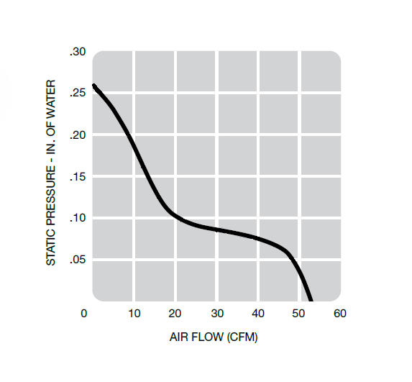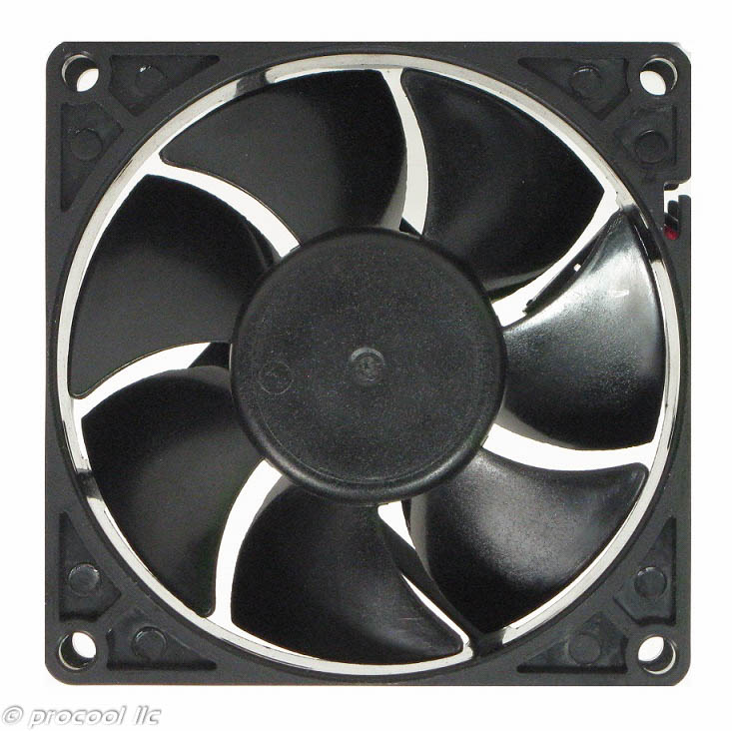

|  |  |
| --- | --- |
| Model TV80 Specifications | |
| Fan Size: | 80mm x 80mm x 25mm |
| Speed: | 4200 RPM |
| Air Flow: | 53 CFM |
| Static Pressure: | 0.260 in H²O |
| Noise: | 39 dBA |
| Thermistor Probe length | n/a |
| Grills/Guards: | Black Wire |
| Bearings: | Precision Ball Bearings |
| Voltage Range: | 6 ~ 13.8VDC |
| Rated Voltage: | 12VDC |
| Current draw: | 0.48A |
| Power consumption: | 5.6w |
| Weight: | 2.79 oz. |
| Operating Temperature: | 14 ~ 158°F (-10 ~ 70°C) |
| Storage Temperature: | -40 ~ 158°F (-40 ~ 70°C) |

|  |
| --- |
| MTBF Hours |
| Has not been evaluated |

**Maintenance:**

Cleaning the fan is the best preventative maintenance. Cleaning frequency would depend on the environment. It is recommended that the blade be cleaned to prevent any buildup of dust. Canned air works well.

**Warranty:**

3 Years from the date of purchase.