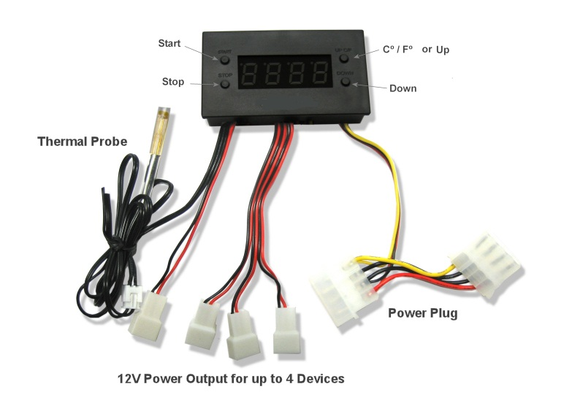

**Features:**  
* 24” thermal probe (48” probes are available separately)  
* 4 3 pin connectors  
* 4 pin Molex pass through connector  
* Option to switch display from Fahrenheit and Celsius.  
* Fully programmable from 32-211 degrees F (0-100 Celsius)  
* On temperature must be 2F (1C) above shut off temperature  
* Can handle up to 2A (2,000mA) device current draw  
* Works with many 12V devices, such as fans and lights

**Dimensions:**   
Device: 71mm x 40mm x 17mm  
Cutout: 68mm x 37mm  
Wall mount plate: 113mm x 82mm  
Shelf mount plate: 93mm x 62mm

**Instructions:**   
Set Start Temp: Press “start button” to put it in start programming mode and the start up temp. will blink. Use the Up/Down buttons on the right to set the desired temperature. (Note: On temperature must be 2F (1C) above shut off temperature) Press the start button again to set the temperature and return to the display readout.

Set Stop Temp: Press “stop button” once to put the unit in stop programming mode and the turn off temperature will blink. Use the Up/Down buttons on the right to set the desired stop temperature. (Note: On temperature must be 2F (1C) above shut off temperature) Press the stop button again to set the temperature and return to the real time temperature readout.

C/F or Up: Will change the display from Fahrenheit to Celsius or will increase the temp when in start or stop programming modes.  
Down: Will decrease the temp when in the start or stop programming modes.

Note: Not tested at extreme temperatures.   
Patent Pending

ProCooL is proud to offer the latest addition to the Home AV Cooling Family of products. This Thermal Fan Controller will allow the user to control the temperature at which the fans turn on and off. The LED display shows the actual temperature in Celsius or Fahrenheit. Controls up to (4) 12VDC fans or any other 12VDC devices.