ProCooL_LOGO 3.jpg

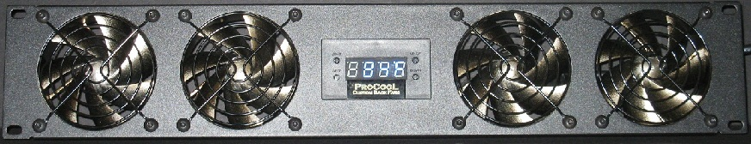ProCooL_LOGO 3.jpg

\* Model No. SP480X-1432

\* (2U) 19” x 3.5” x 1.5”

\* Airflow = 128 CFM   
\* Noise = 20 dBA

\* 4 Silent 80mm Fans

\* 4 Black Wire Guards  
  
\* Large LED display  
  
\* Displays current temp in Fahrenheit or Celsius.  
  
\* Fully programmable from 32-211 degrees F  
 (0-100 Celsius)  
  
\* 110-240 VAC, 50/60 Hz Power supply included.  
\* 24” thermal probe   
 (48” probes are available separately)

Note: Not tested at extreme temperatures.   
Patent Pending

**Instructions:**

**PROBE:** Place the end of the temperature probe where you want it to detect the temperature. It can be left as is on the panel for an ambient temp. Or it can be placed at the top of a cabinet or above a hot component. The fan panel placement depends on airflow direction. Try to avoid placing the probe where the fans will blow directly on it.  
**START**: Press “START button” to put the unit in START up programming mode. The start temp will blink. Use the Up/Down buttons on the right to set the desired temperature where the fans will turn on. (Note: The ON temperature must be 2F (1C) above shut off temperature) Press the start button again to set the temperature and return to the display readout.

**STOP**: Press “STOP button” once to put the unit in STOP programming mode and the stop temperature will blink. Use the Up/Down buttons on the right to set the desired stop temperature. (Note: The On temperature must be 2F (1C) above shut off temperature) Press the stop button again to set the temperature and return to the real time temperature readout.

**C/F or UP**: Will change the display from Fahrenheit to Celsius or will increase the temp when in start or stop programming modes.  
  
**DOWN**: Will decrease the temp when in the start or stop programming modes.